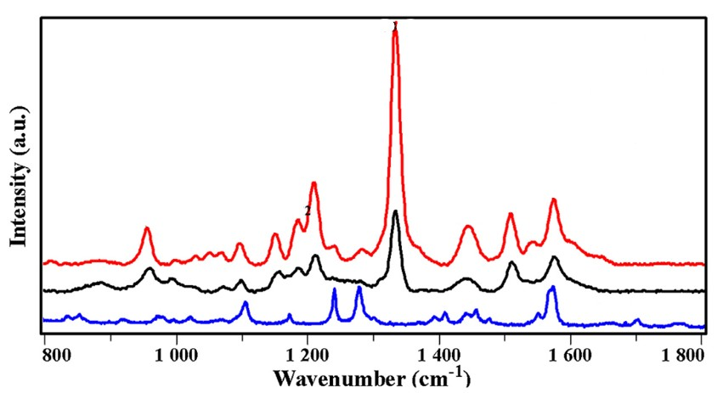

Figure 1: [https://doi.org/10.1016/j.snb.2016.11.021](https://doi.org/10.1016/j.snb.2016.11.021" \t "_blank" \o "Persistent link using digital object identifier)

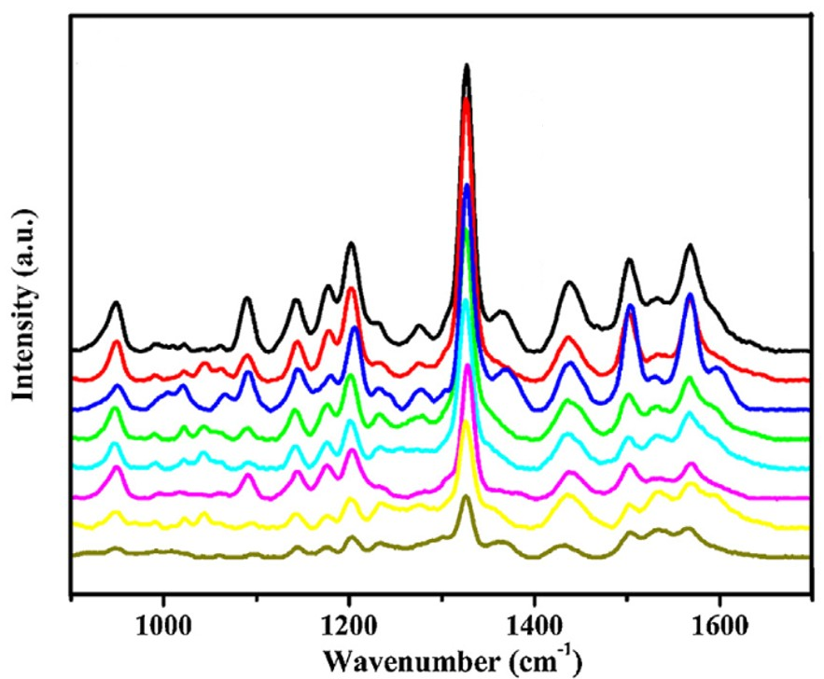

Figure 2: [https://doi.org/10.1016/j.snb.2016.11.021](https://doi.org/10.1016/j.snb.2016.11.021" \t "_blank" \o "Persistent link using digital object identifier)

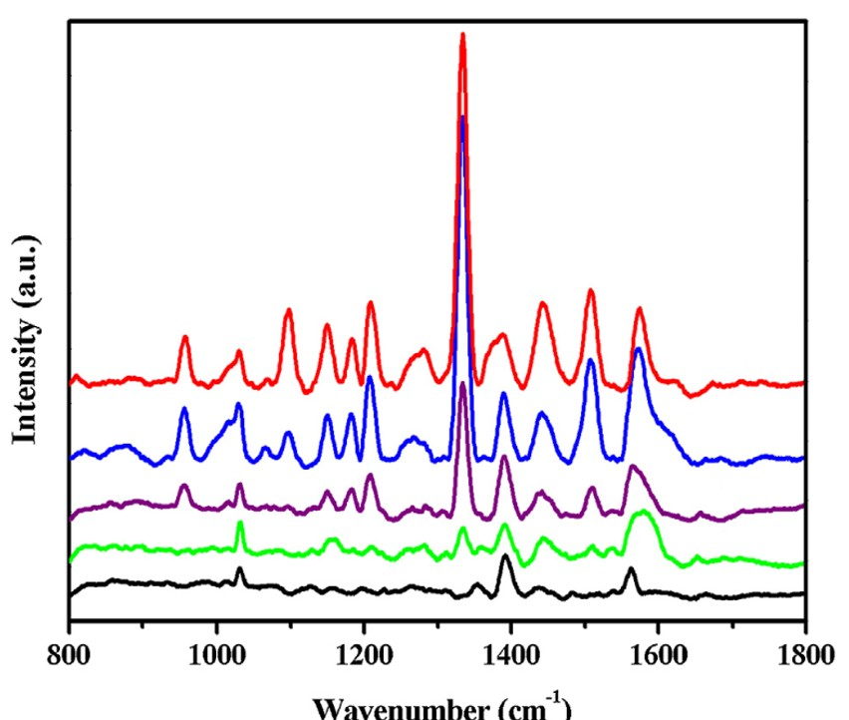

Figure 3: [https://doi.org/10.1016/j.snb.2016.11.021](https://doi.org/10.1016/j.snb.2016.11.021" \t "_blank" \o "Persistent link using digital object identifier)

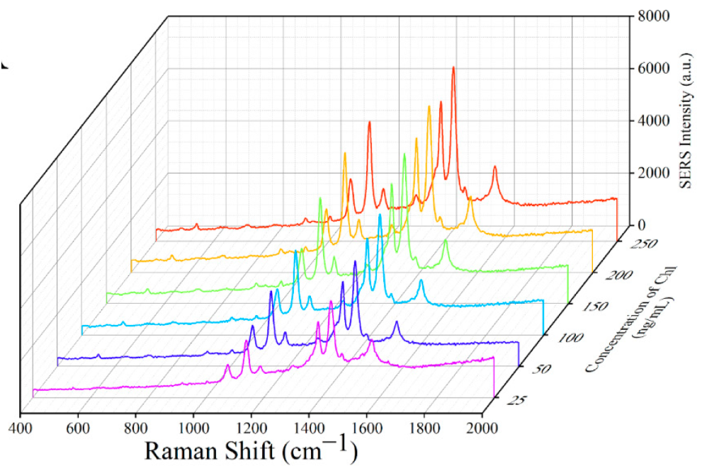

Figure 4: **<https://doi.org/10.3390/foods11213331>**

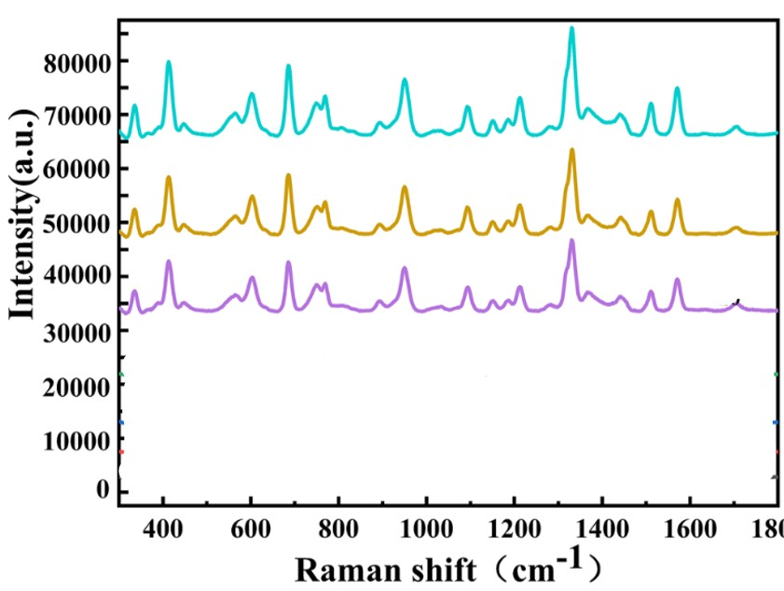

Figure 5: <https://doi.org/10.1007/s00217-019-03408-8>

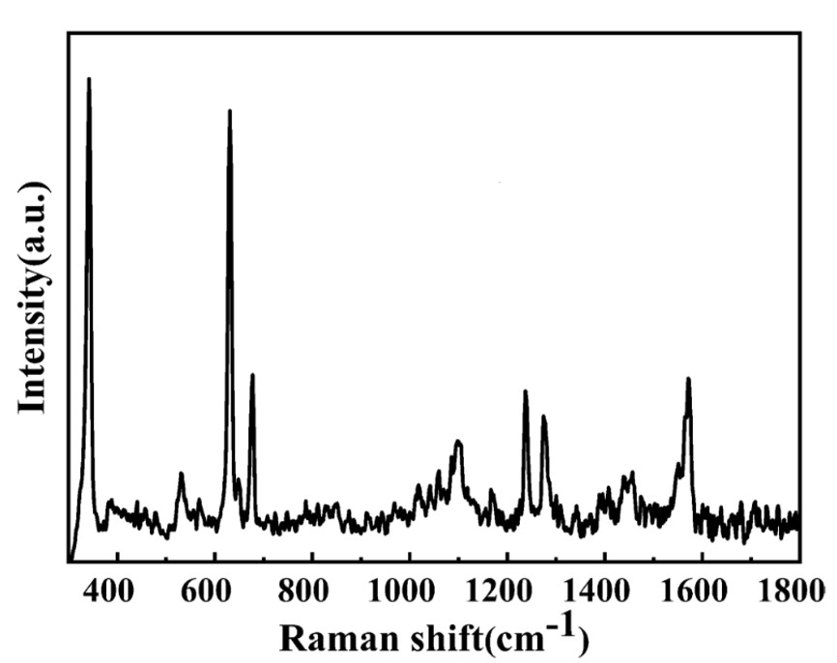

Figure 6: <https://doi.org/10.1007/s00217-019-03408-8>

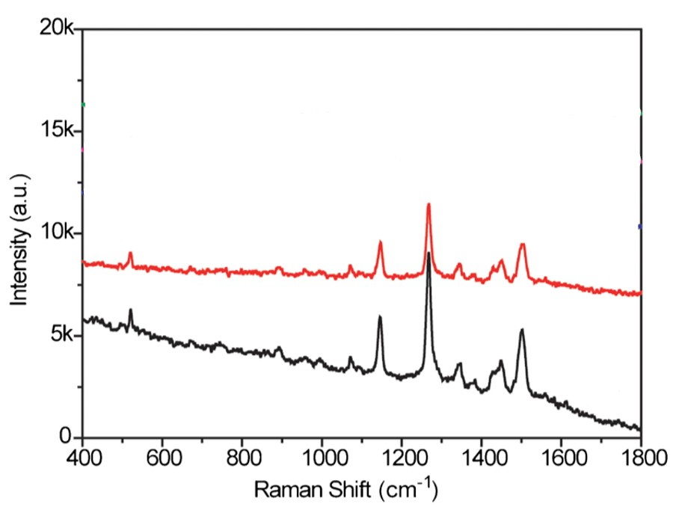

Figure 7:https://doi.org/10.1007/s00604-022-05261-1

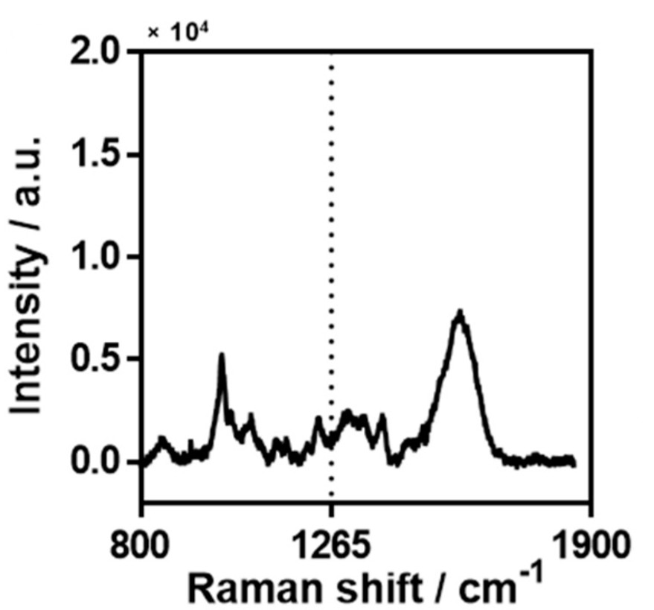

Figure 8:https://doi.org/10.1007/s00604-022-05261-1

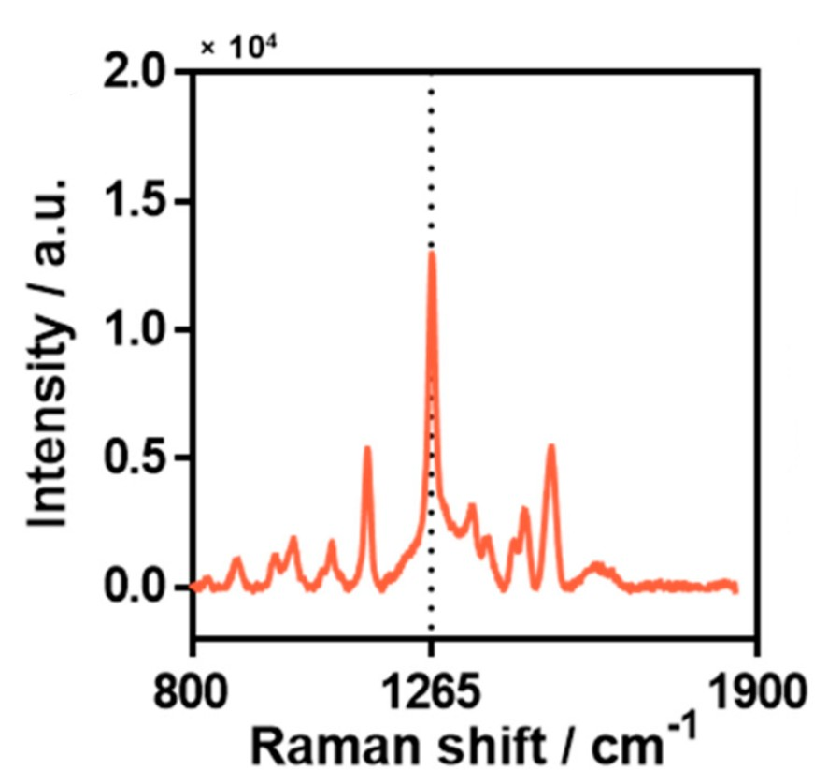

Figure 9:https://doi.org/10.1007/s00604-022-05261-1

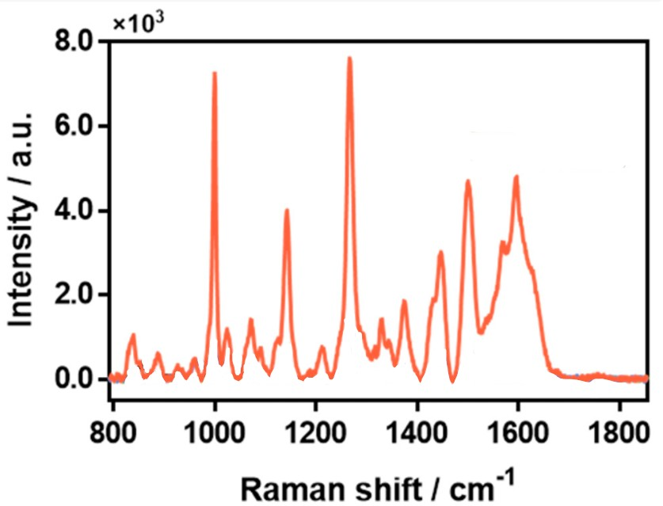

Figure 10:https://doi.org/10.1007/s00604-022-05261-1

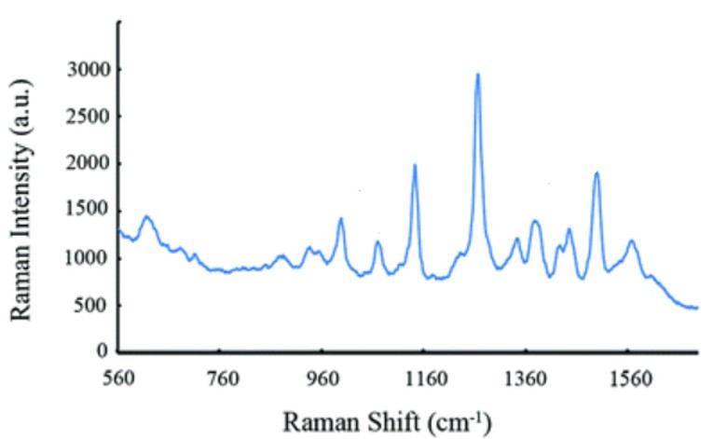

Figure 11: 10.6023/A15050326

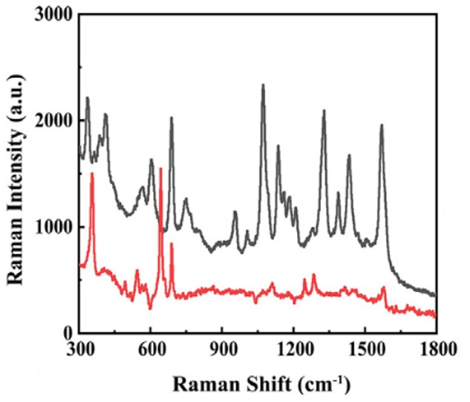

Figure 12: [https://doi.org/10.1016/j.saa.2021.119996](https://doi.org/10.1016/j.saa.2021.119996" \t "_blank" \o "Persistent link using digital object identifier)

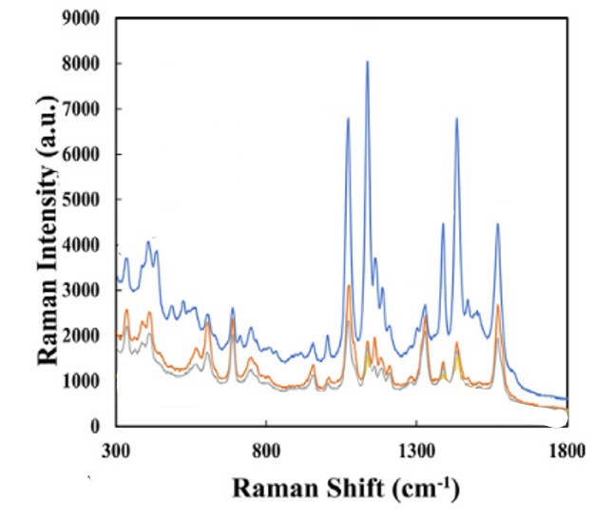

Figure 13: [https://doi.org/10.1016/j.saa.2021.119996](https://doi.org/10.1016/j.saa.2021.119996" \t "_blank" \o "Persistent link using digital object identifier)

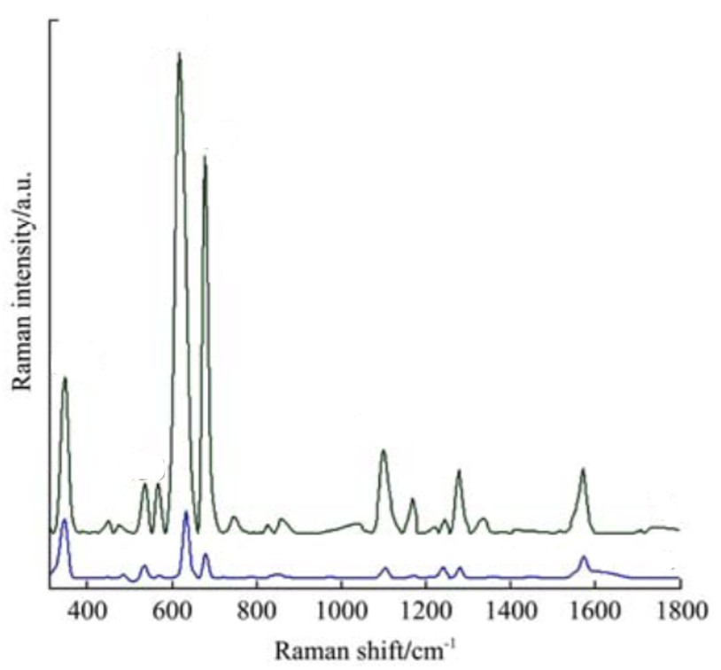

Figure 14: 10.3965/j.ijabe.20150805.1771

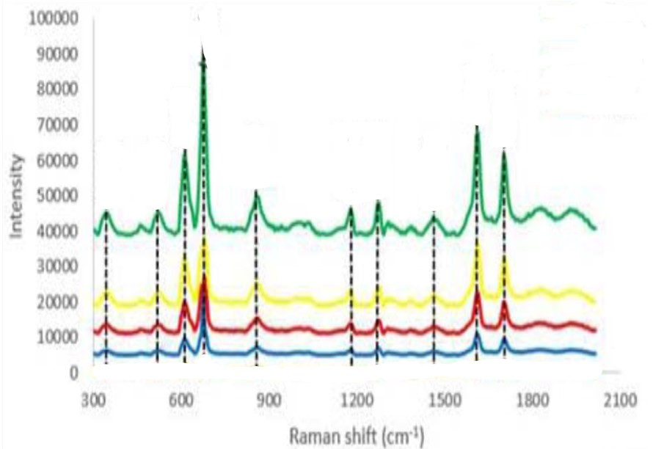

Figure 15: 10.1088/1742-6596/1795/1/012035

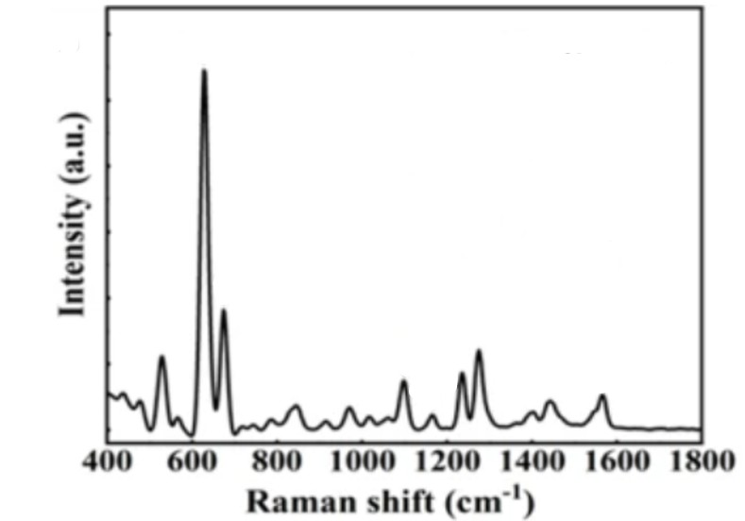

Figure 16: <https://doi.org/10.1038/s41598-023-45954-y>

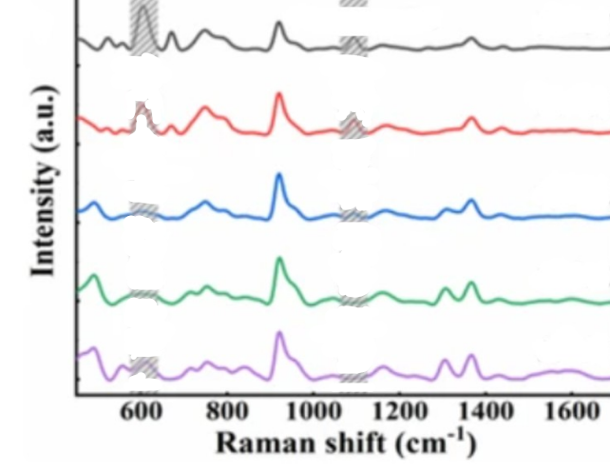

Figure 17: <https://doi.org/10.1038/s41598-023-45954-y>

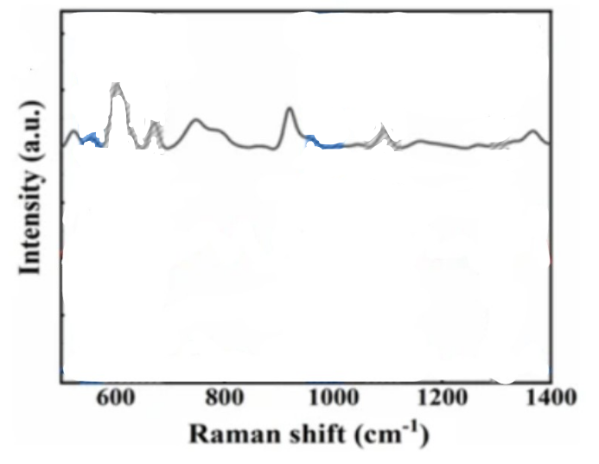

Figure 18: <https://doi.org/10.1038/s41598-023-45954-y>

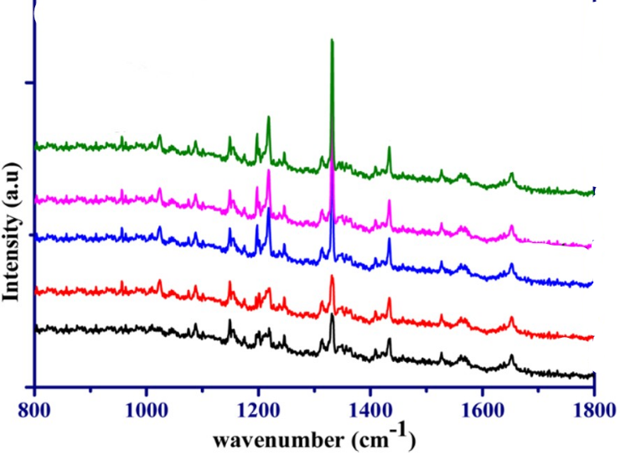

Figure 19: [https://doi.org/10.1016/j.jfca.2021.104330](https://doi.org/10.1016/j.jfca.2021.104330" \t "_blank" \o "Persistent link using digital object identifier)

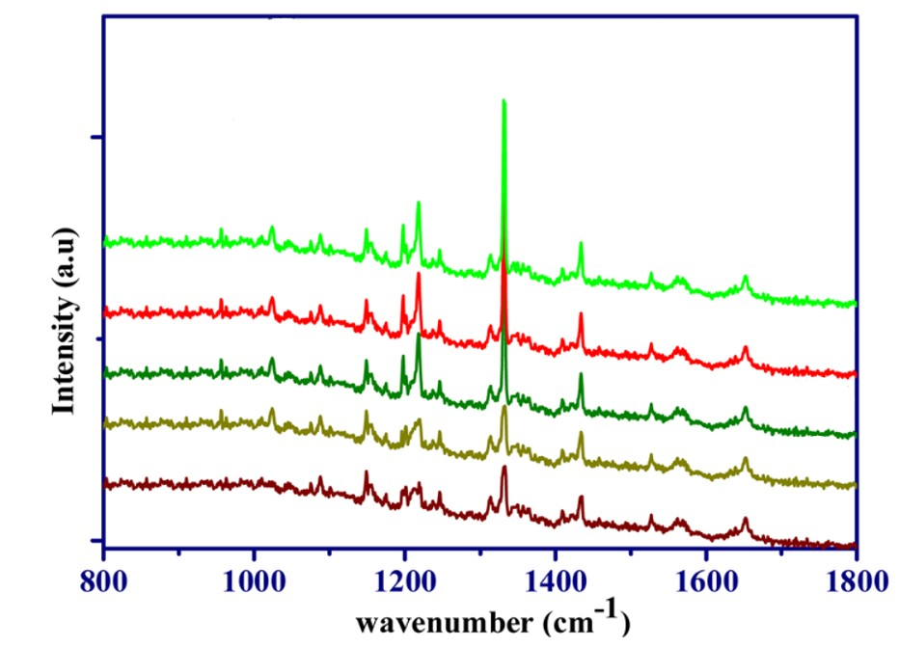

Figure 20: [https://doi.org/10.1016/j.jfca.2021.104330](https://doi.org/10.1016/j.jfca.2021.104330" \t "_blank" \o "Persistent link using digital object identifier)

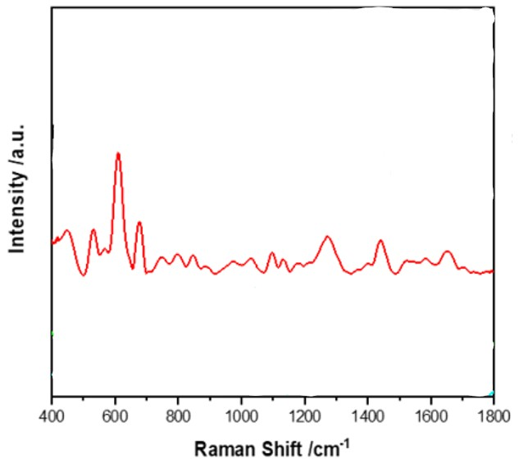

Figure 21: [https://doi.org/10.1016/j.microc.2023.109352](https://doi.org/10.1016/j.microc.2023.109352" \t "_blank" \o "Persistent link using digital object identifier)

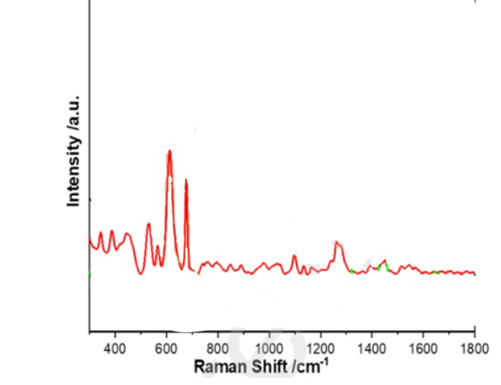

Figure 22: [https://doi.org/10.1016/j.microc.2023.109352](https://doi.org/10.1016/j.microc.2023.109352" \t "_blank" \o "Persistent link using digital object identifier)

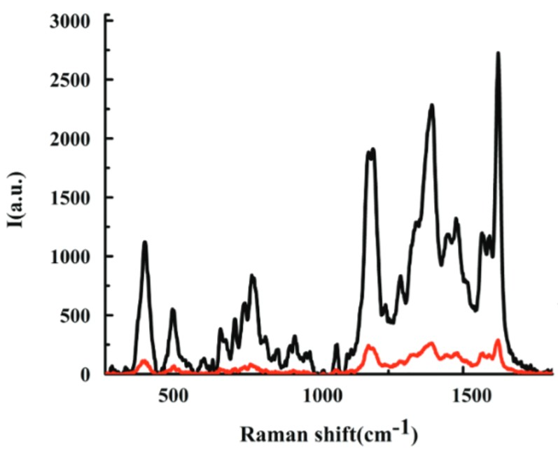

Figure 23: 10.1166/mex.2023.2385

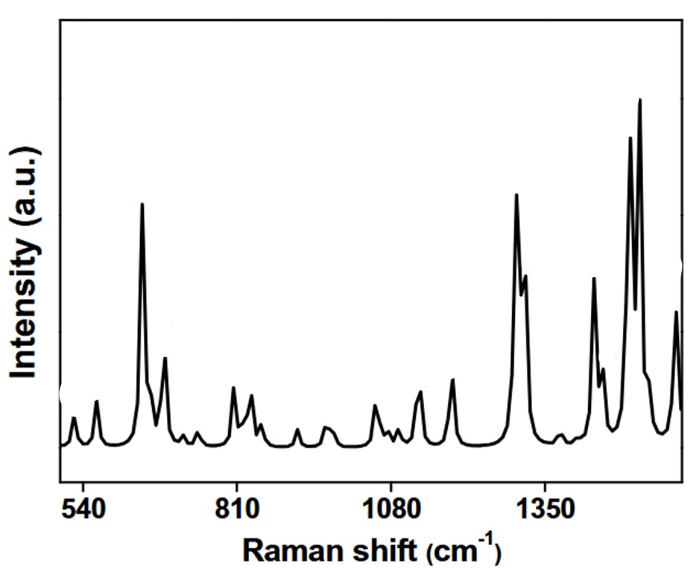

Figure 24: <https://doi.org/10.1007/s00216-019-02103-7>

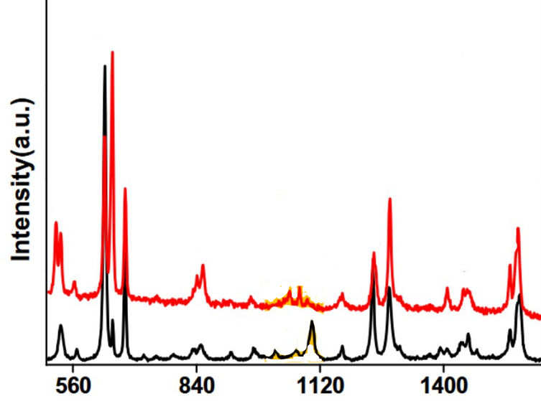

Figure 25: <https://doi.org/10.1007/s00216-019-02103-7>

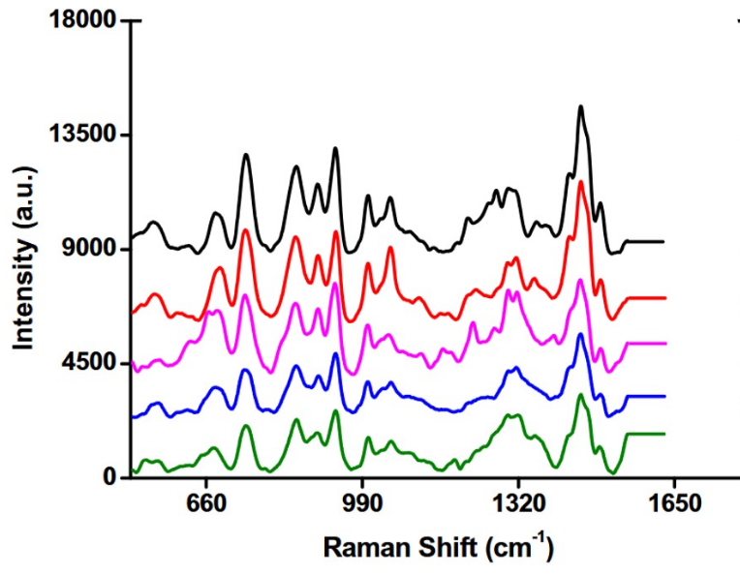

Figure 26: <https://doi.org/10.1007/s00216-019-02103-7>

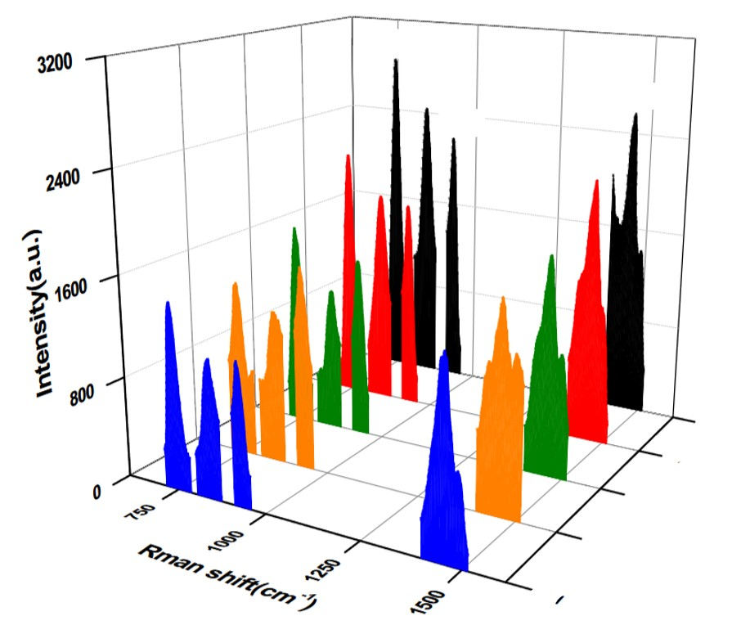

Figure 27: <https://doi.org/10.1007/s00216-019-02103-7>

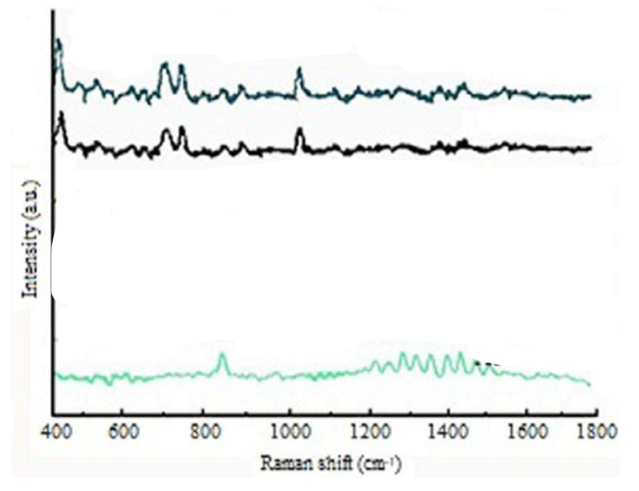

Figure 28: <https://doi.org/10.1002/jsfa.12098>

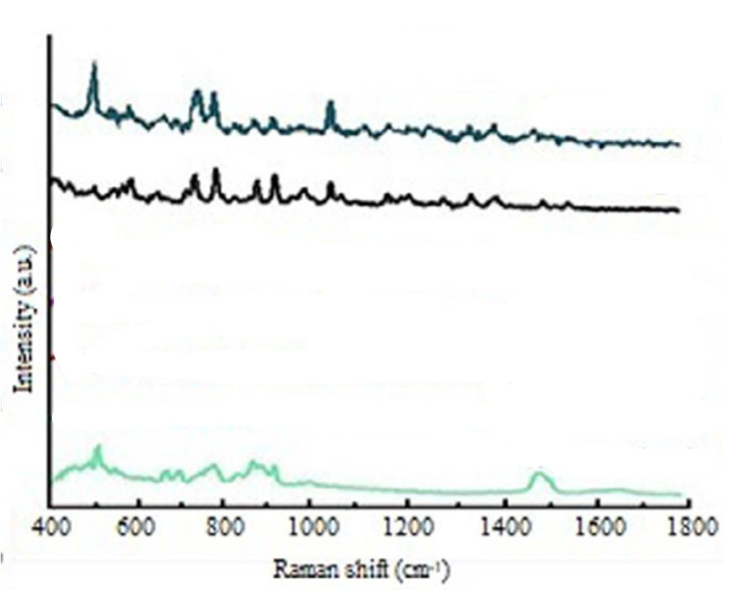

Figure 29: <https://doi.org/10.1002/jsfa.12098>

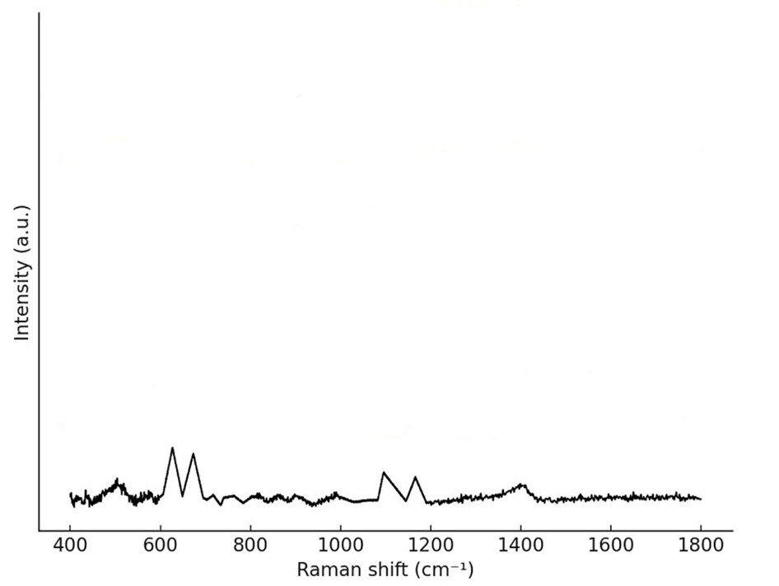

Figure 30: <https://doi.org/10.1371/journal.pone.0320456>

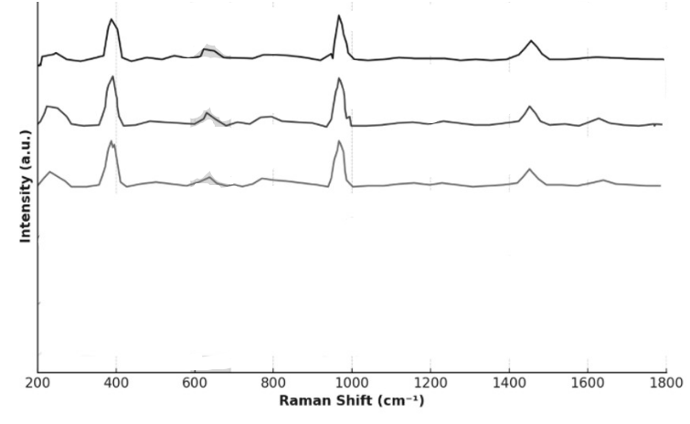

Figure 31: <https://doi.org/10.1371/journal.pone.0320456>

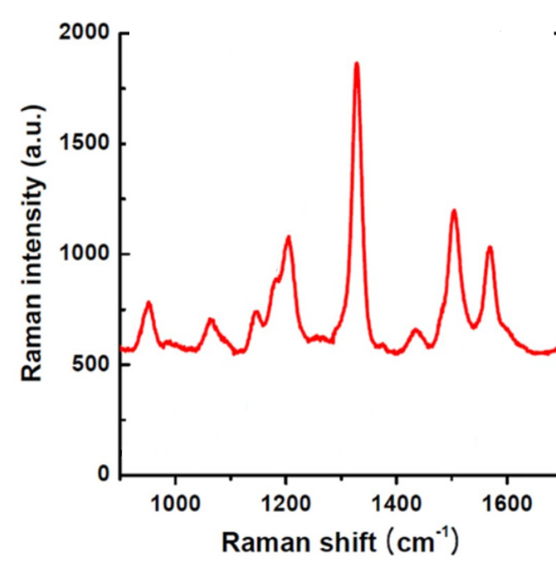

Figure 32: 10.1088/0957-4484/26/1/015502

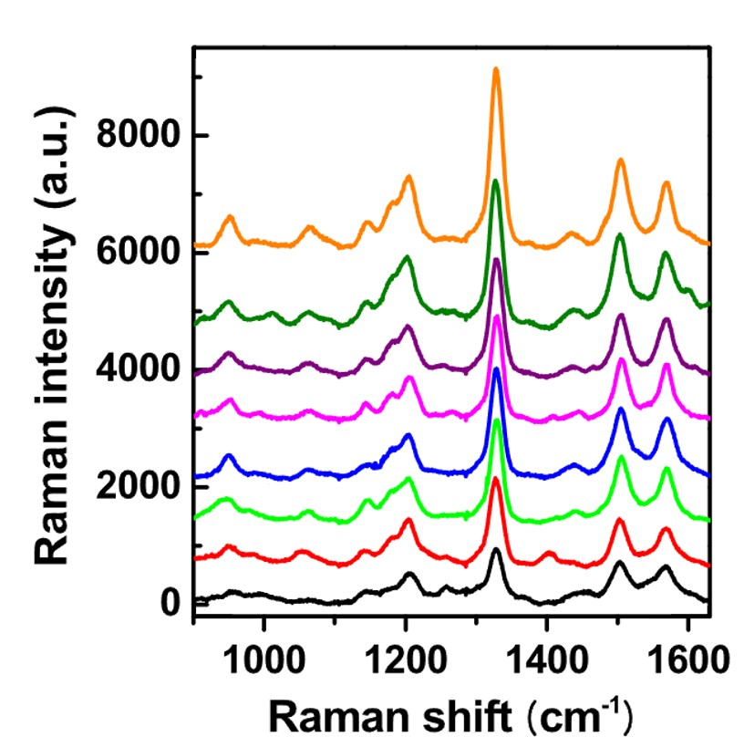

Figure 33: 10.1088/0957-4484/26/1/015502

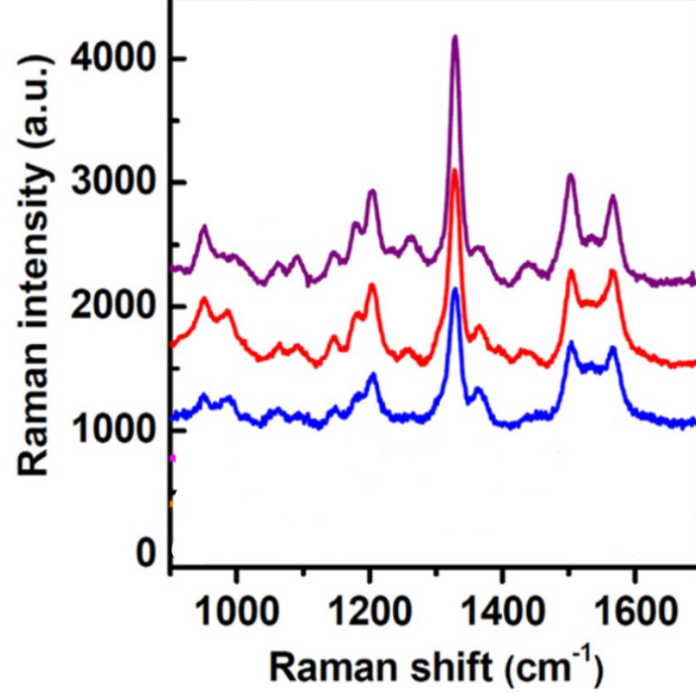

Figure 34: 10.1088/0957-4484/26/1/015502

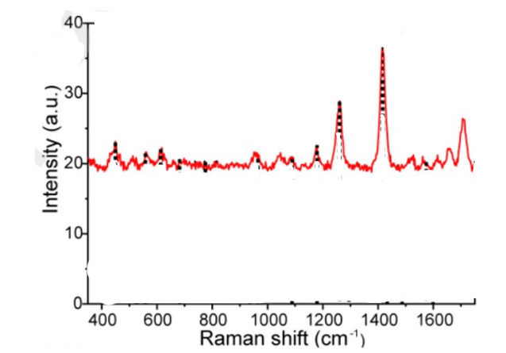

Figure 35: [https://doi.org/10.1016/j.saa.2023.123665](https://doi.org/10.1016/j.saa.2023.123665" \t "_blank" \o "Persistent link using digital object identifier)

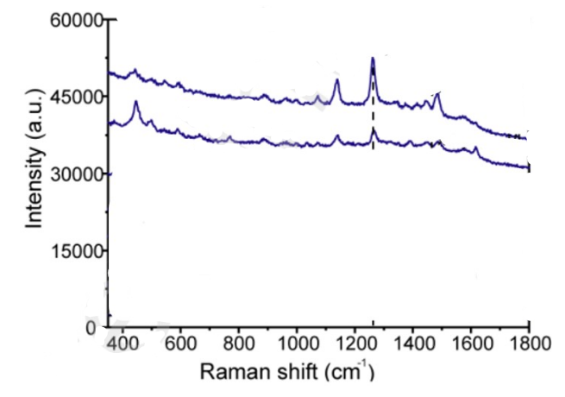

Figure 36: [https://doi.org/10.1016/j.saa.2023.123665](https://doi.org/10.1016/j.saa.2023.123665" \t "_blank" \o "Persistent link using digital object identifier)

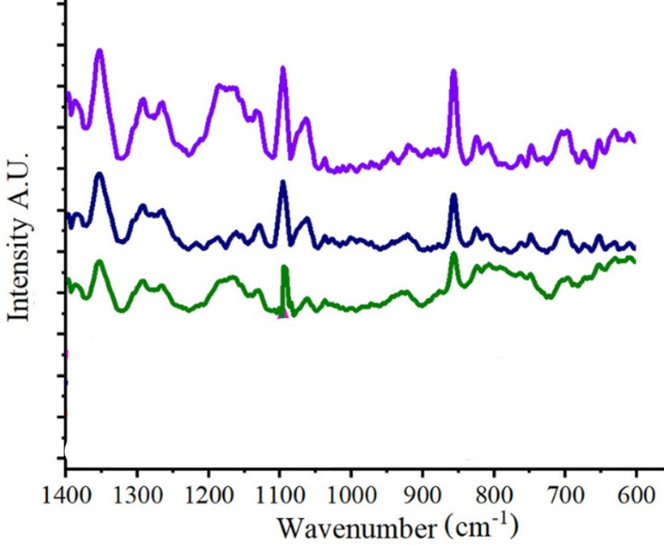

Figure 37: [https://doi.org/10.1016/j.snb.2019.02.084](https://doi.org/10.1016/j.snb.2019.02.084" \t "_blank" \o "Persistent link using digital object identifier)

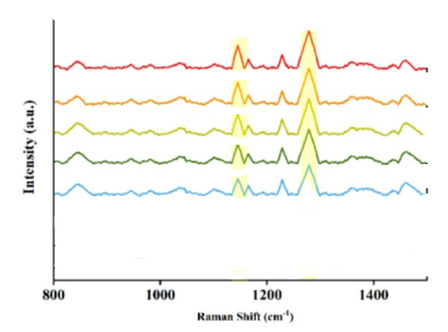

Figure 38: 10.2139/ssrn.4728826

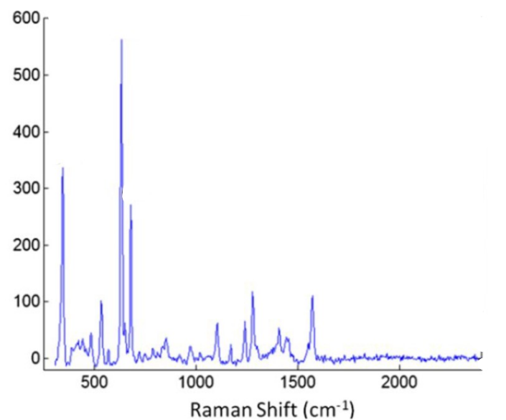

Figure 39: <https://doi.org/10.1117/12.2050137>

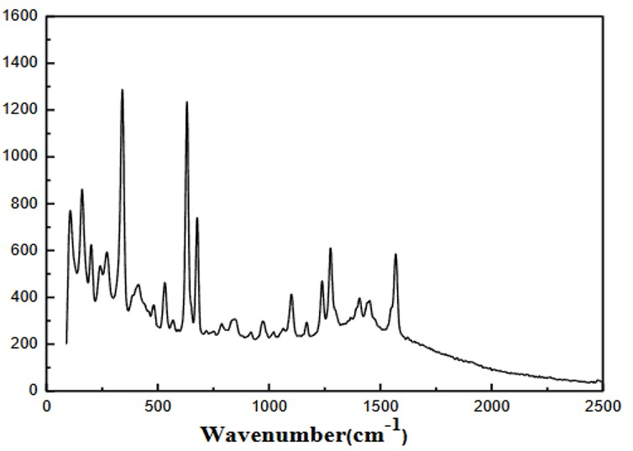

Figure 40: <https://doi.org/10.1007/978-3-319-48357-3_56>

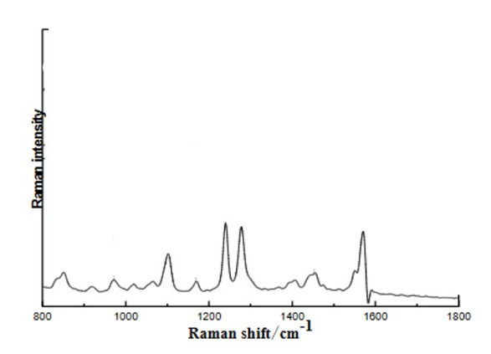

Figure 41: <https://doi.org/10.1007/978-3-319-48357-3_56>

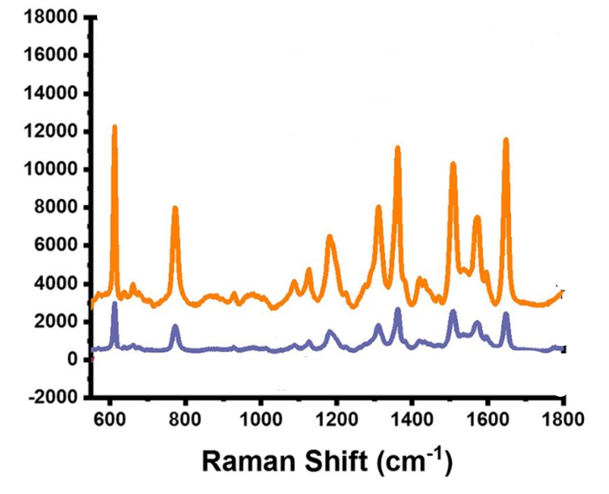

Figure 42: <https://doi.org/10.1007/s11468-022-01618-7>

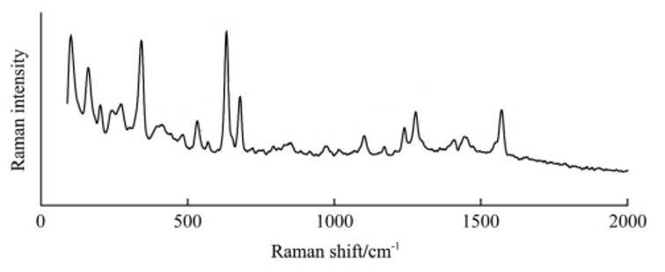

Figure 43: 10.3965/j.ijabe.20160902.1960

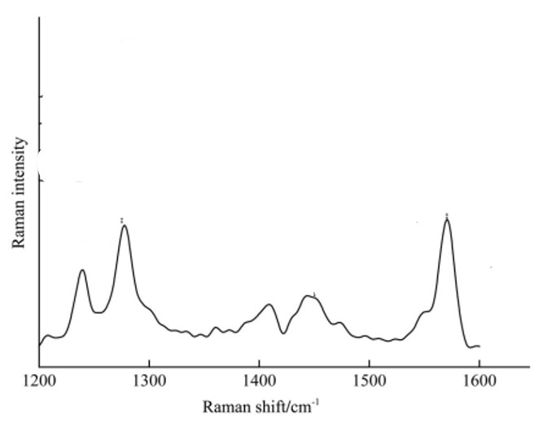

Figure 44: 10.3965/j.ijabe.20160902.1960

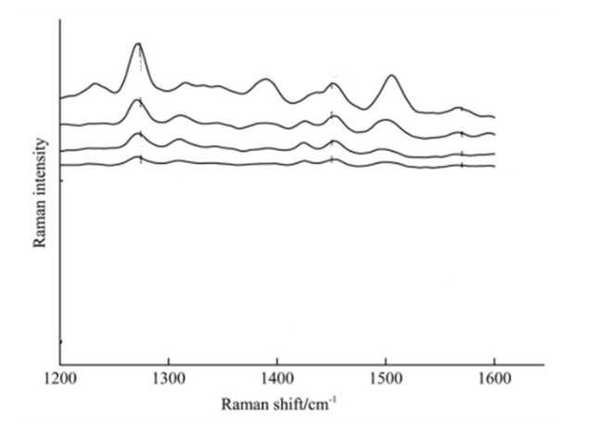

Figure 45: 10.3965/j.ijabe.20160902.1960

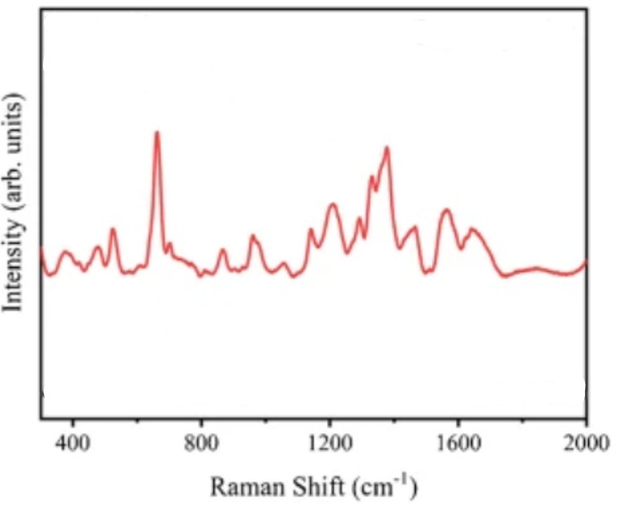

Figure 46: <https://doi.org/10.1007/s00216-025-05903-2>

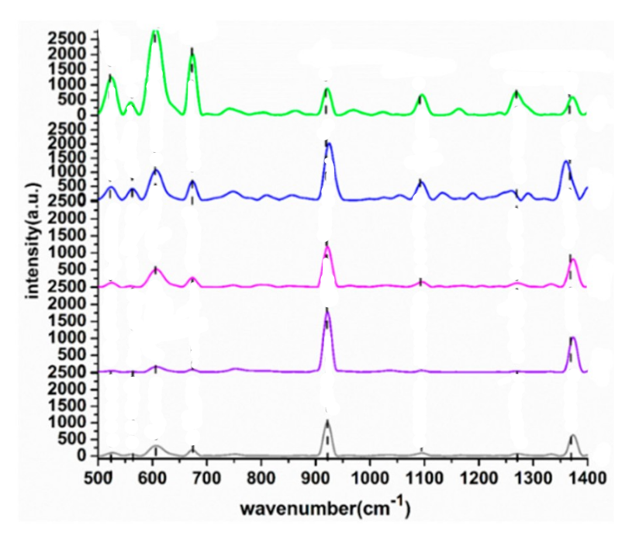

Figure 47: **[ttps://doi.org/10.3390/ijms20112817](https://doi.org/10.3390/ijms20112817)**

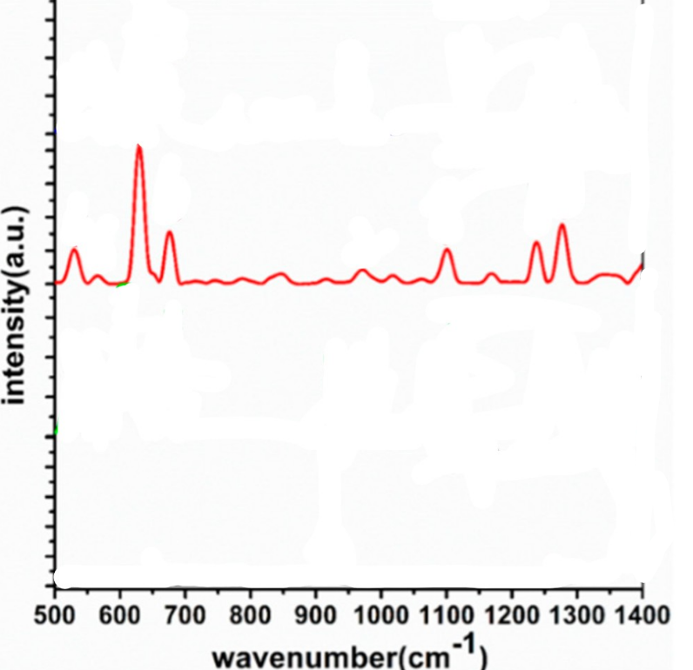Figure 48: **[ttps://doi.org/10.3390/ijms20112817](https://doi.org/10.3390/ijms20112817)**

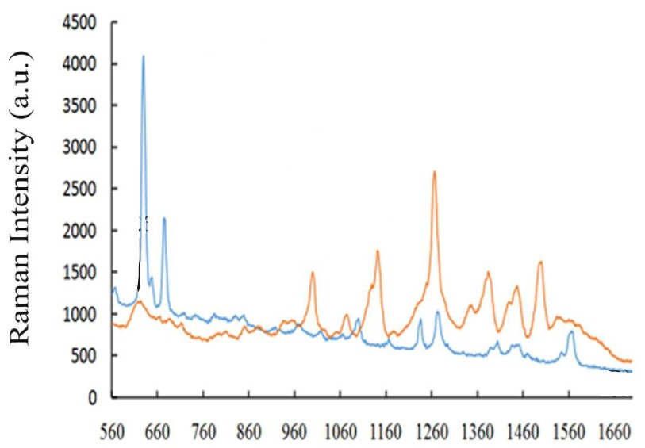

Figure 49: [https://doi.org/10.1016/j.lwt.2018.07.055](https://doi.org/10.1016/j.lwt.2018.07.055" \t "_blank" \o "Persistent link using digital object identifier)

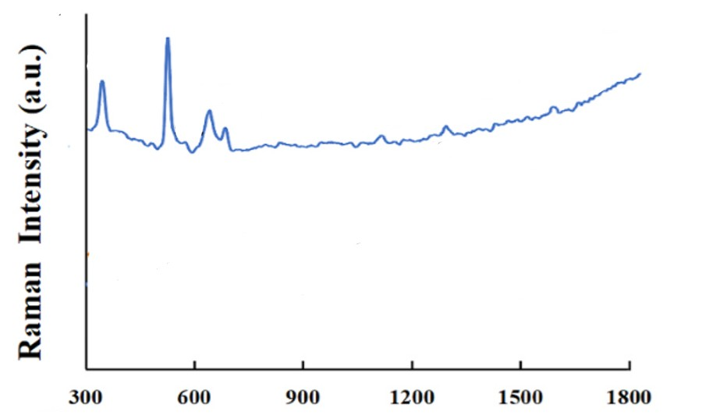

Figure 50: [https://doi.org/10.1016/j.lwt.2022.113804](https://doi.org/10.1016/j.lwt.2022.113804" \t "_blank" \o "Persistent link using digital object identifier)

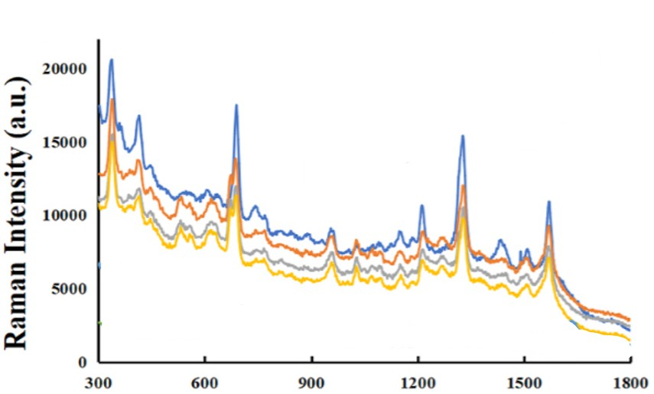

Figure 51: [https://doi.org/10.1016/j.lwt.2022.113804](https://doi.org/10.1016/j.lwt.2022.113804" \t "_blank" \o "Persistent link using digital object identifier)

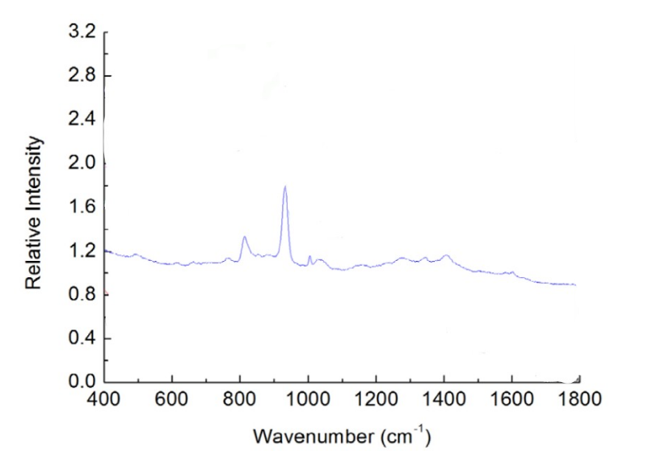

Figure 52: 10.1016/j.lwt.2018.07.055

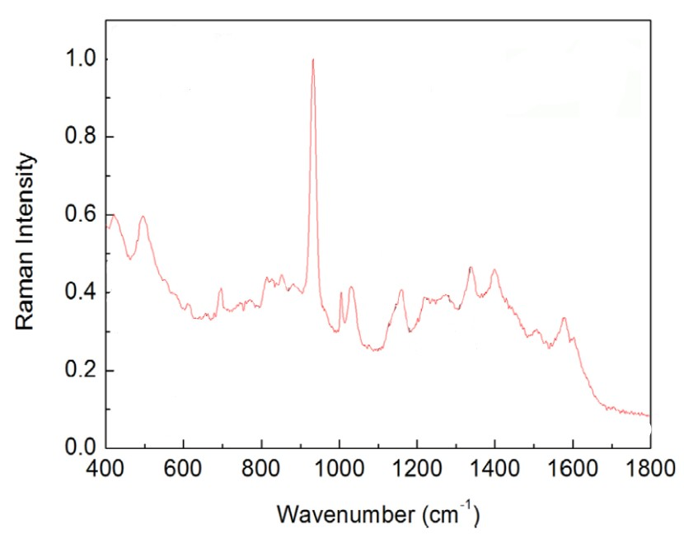

Figure 53: 10.1016/j.lwt.2018.07.055

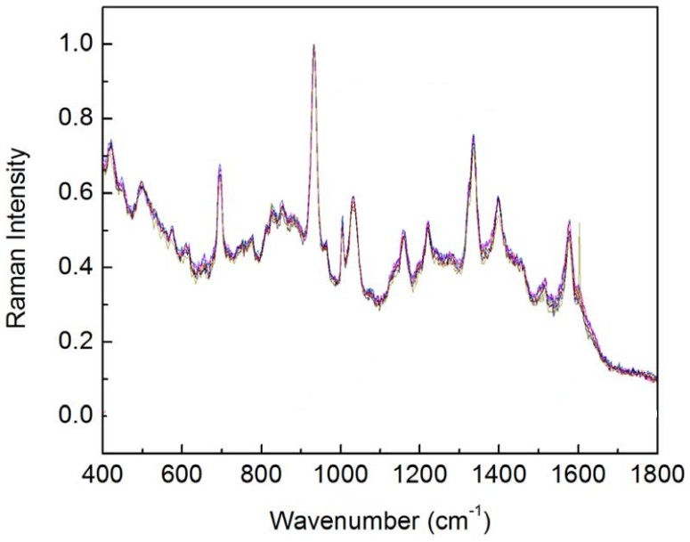

Figure 54: 10.1016/j.lwt.2018.07.055

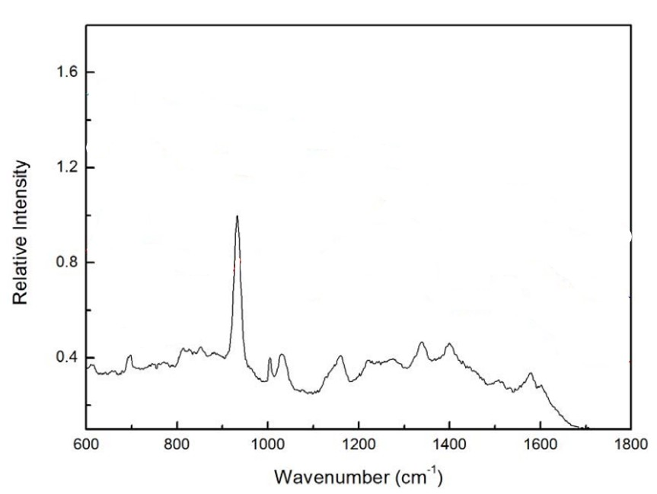

Figure 55: 10.1016/j.lwt.2018.07.055

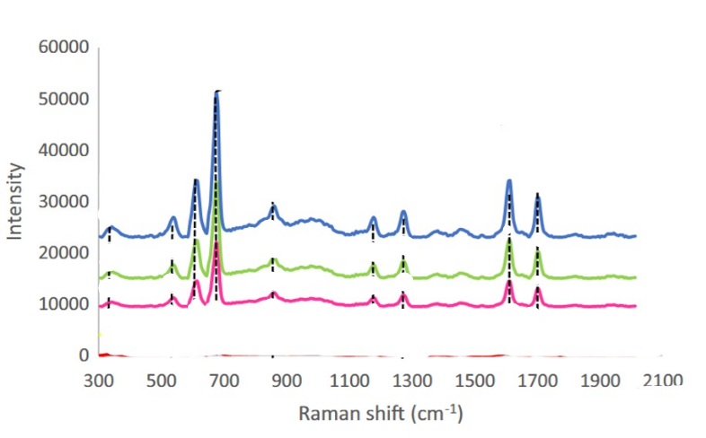

Figure 56: 10.1007/s13404-022-00323-x

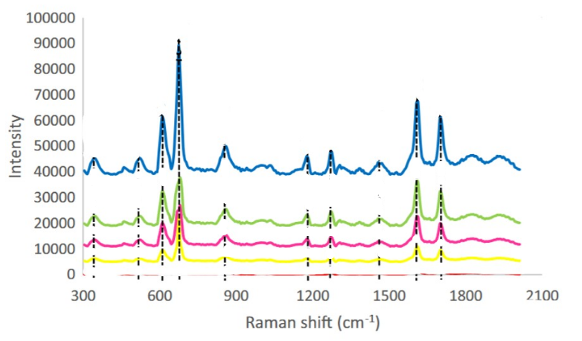

Figure 57: 10.1007/s13404-022-00323-x

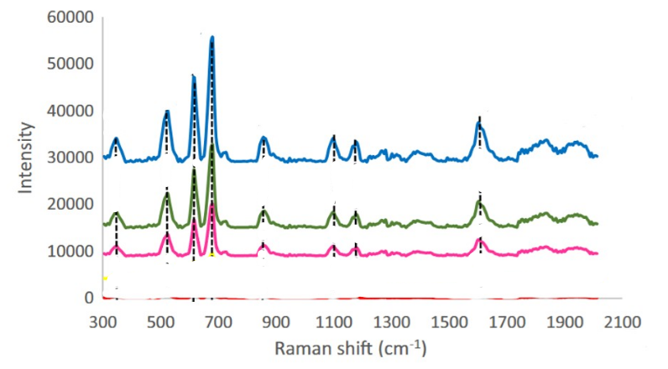

Figure 58: 10.1007/s13404-022-00323-x

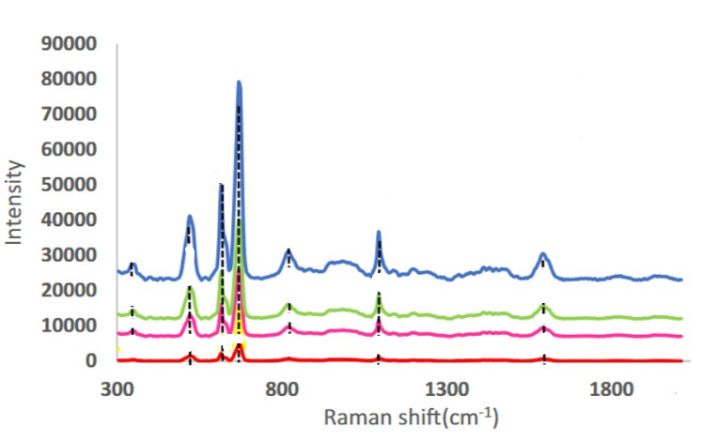

Figure 59: 10.1007/s13404-022-00323-x

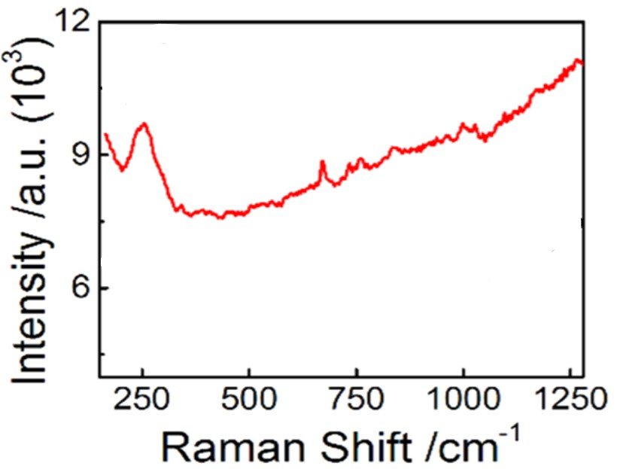

Figure 60: [https://doi.org/10.1021/acs.analchem.5b03735](https://doi.org/10.1021/acs.analchem.5b03735" \o "DOI URL)

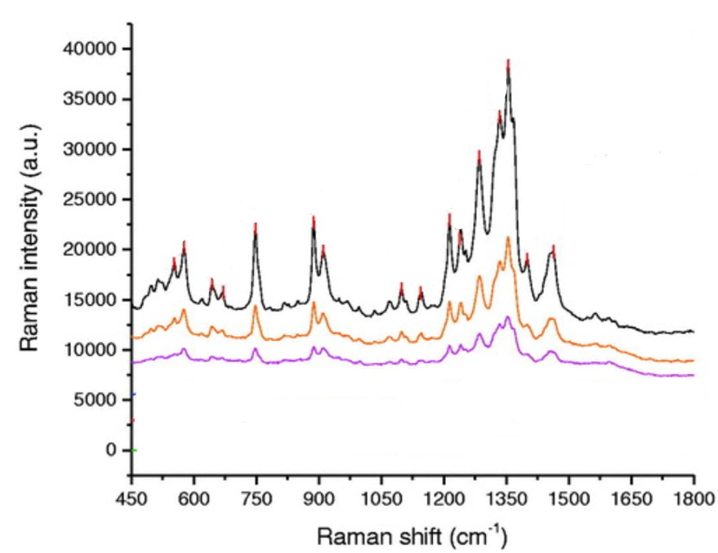

Figure 61: <https://doi.org/10.1080/15599612.2018.1508528>

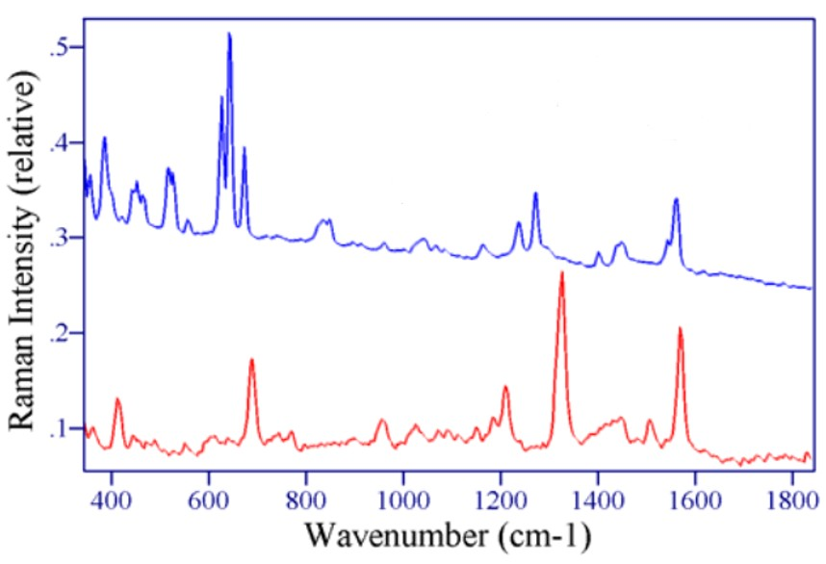

Figure 62:10.1117/12.511941

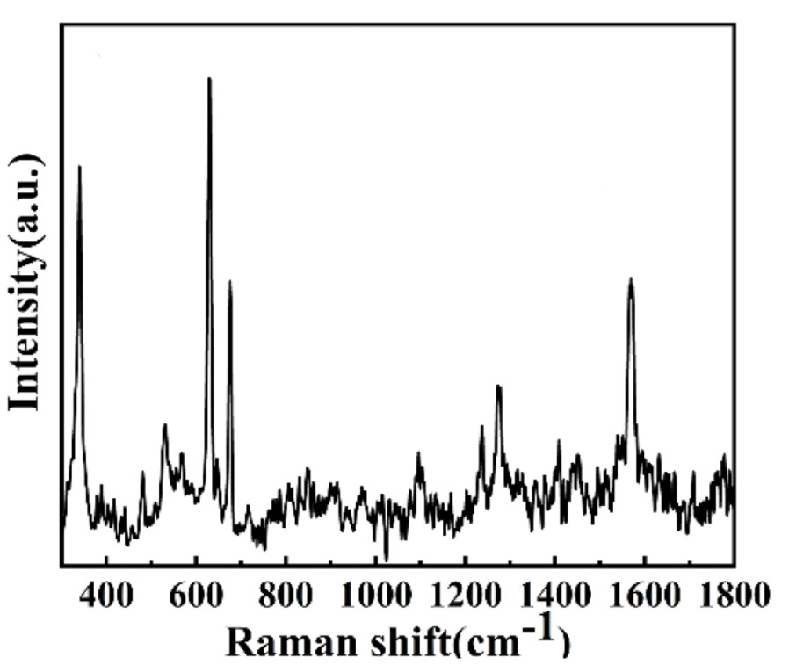

Figure 63 :**<https://doi.org/10.3390/foods11081089>**

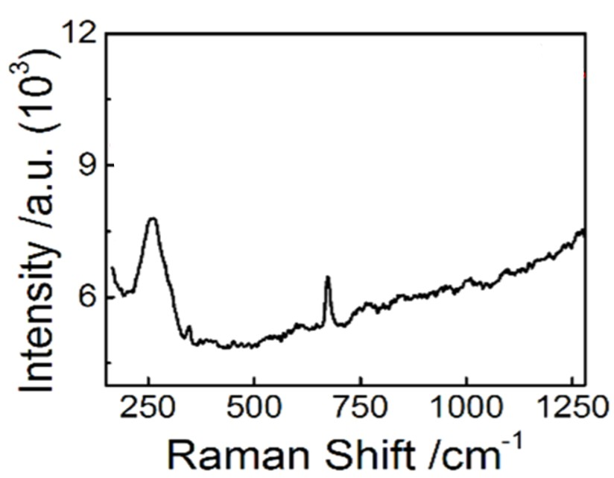

Figure 60: [https://doi.org/10.1021/acs.analchem.5b03735](https://doi.org/10.1021/acs.analchem.5b03735" \o "DOI URL)

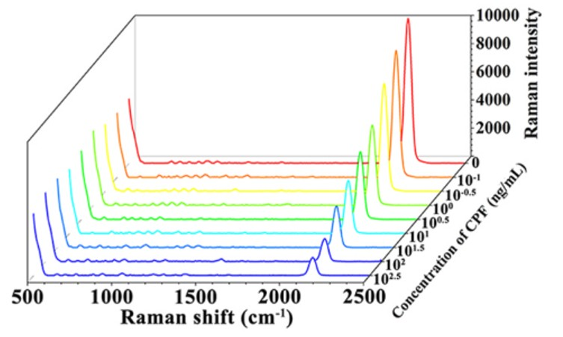

Figure 65: <https://doi.org/10.1016/j.aca.2023.341398>

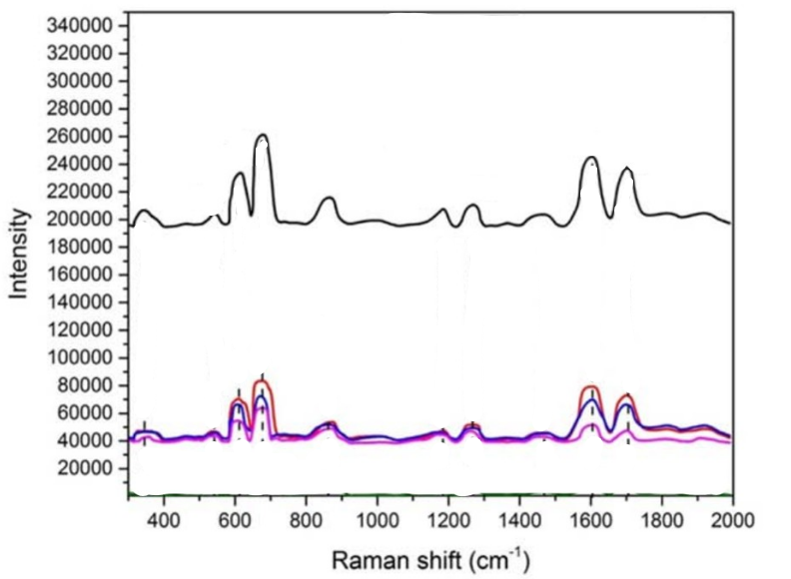

Figure 66: https://doi.org/10.1016/j.optmat.2024.114946

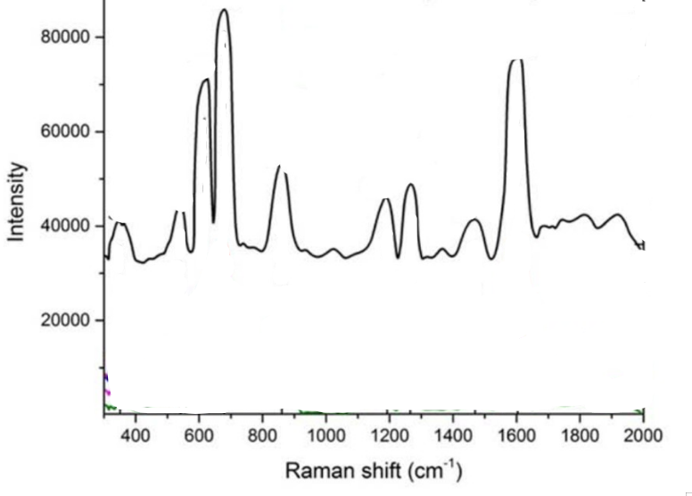

Figure 67: https://doi.org/10.1016/j.optmat.2024.114946

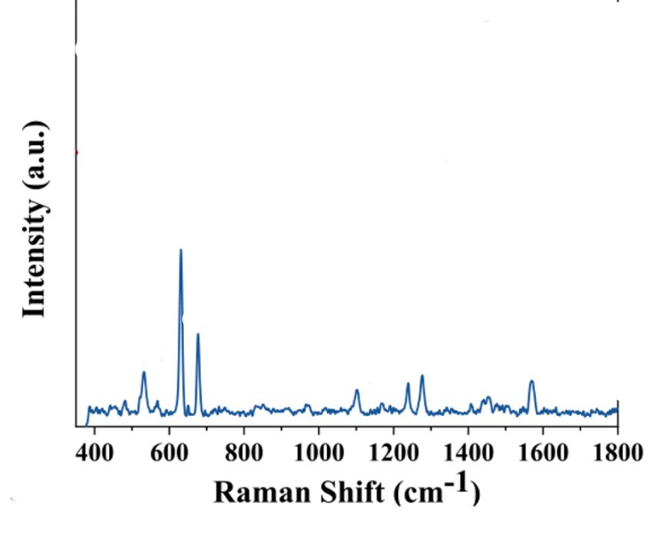

Figure 68: https://doi.org/10.1016/j.foodchem.2024.139944

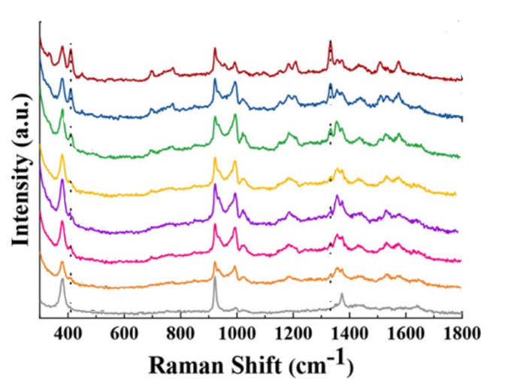

Figure 69: https://doi.org/10.1016/j.foodchem.2024.139944

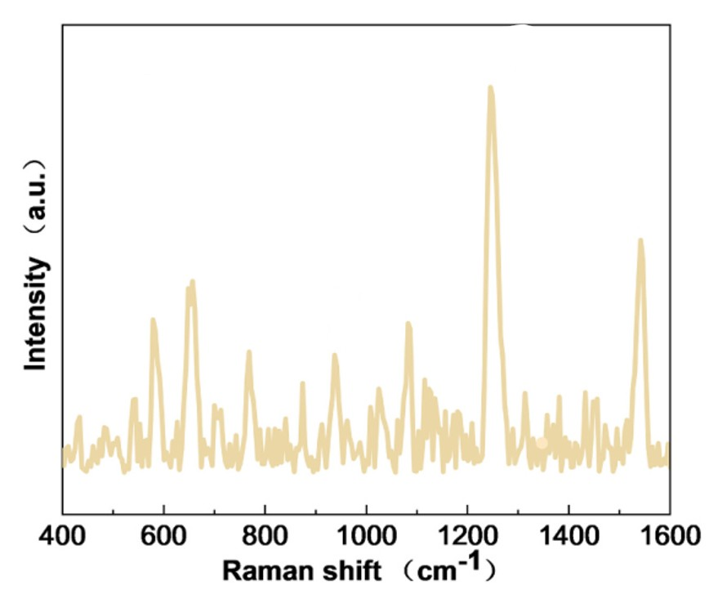

Figure 70: <https://doi.org/10.1016/j.colcom.2023.100728>

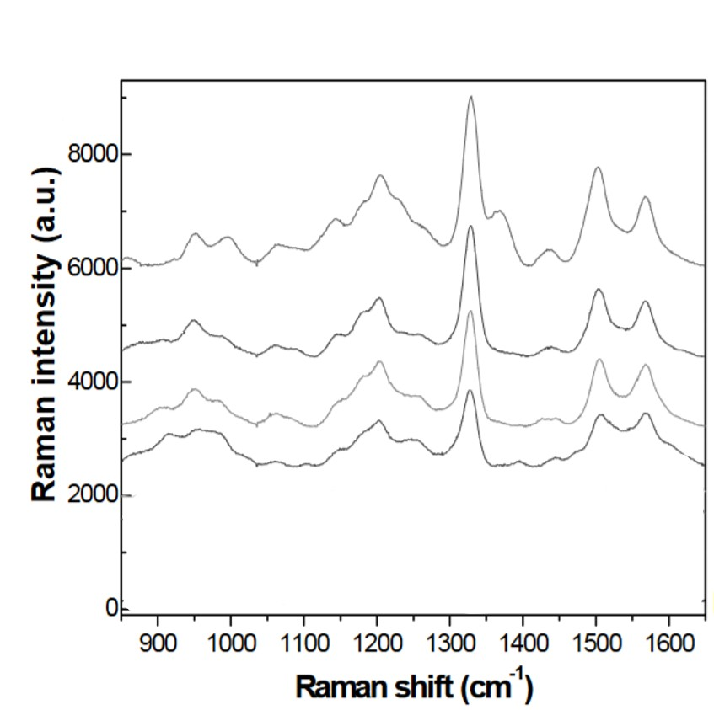

Figure 71: [https://doi.org/10.1557/opl.2011.880](https://doi.org/10.1557/opl.2011.880" \t "_blank)

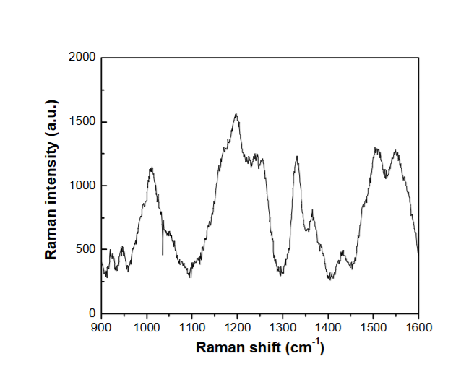

Figure 72: [https://doi.org/10.1557/opl.2011.880](https://doi.org/10.1557/opl.2011.880" \t "_blank)

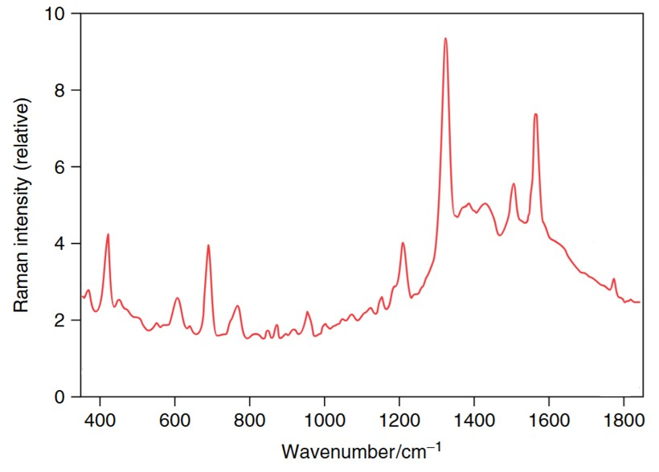

Figure 73: **<https://doi.org/10.1002/0470027320.s8941>**

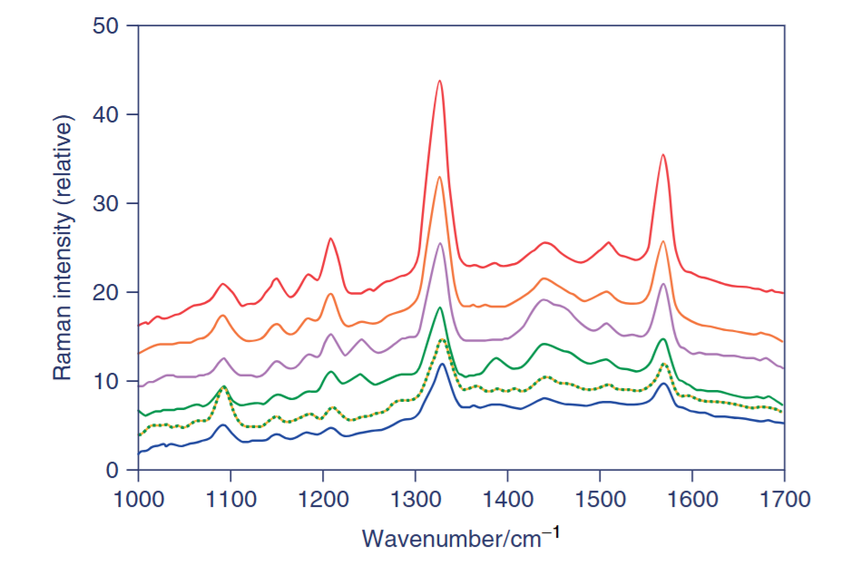

Figure 74: **<https://doi.org/10.1002/0470027320.s8941>**

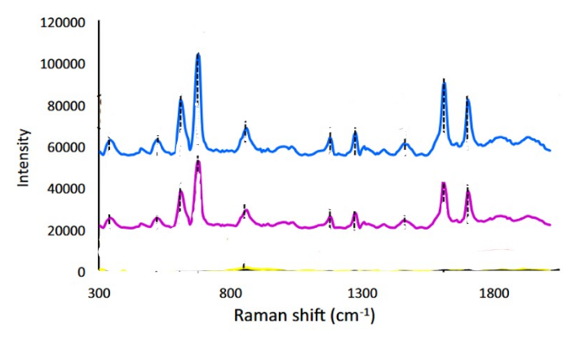

Figure 75: <https://doi.org/10.1007/s10854-021-06381-9>

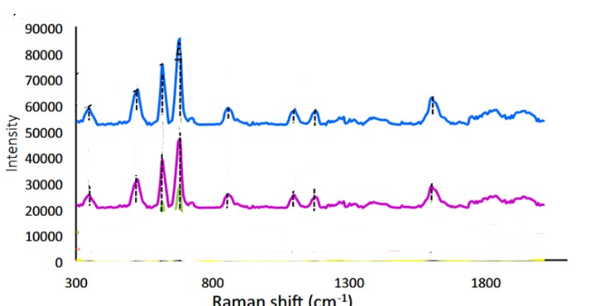

Figure 76: <https://doi.org/10.1007/s10854-021-06381-9>

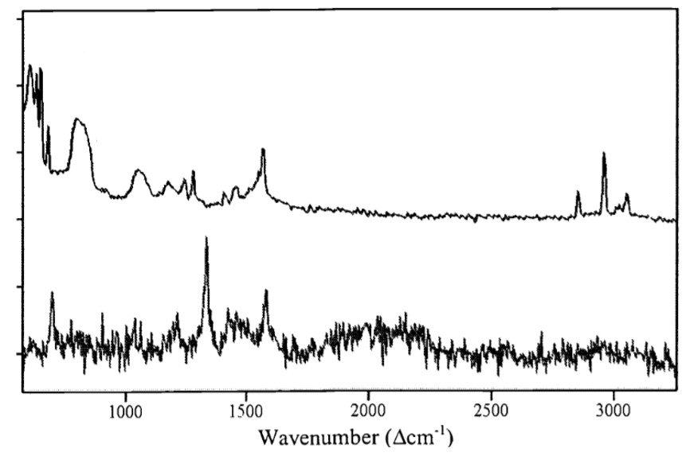

Figure 77: <https://doi.org/10.1117/12.418724>

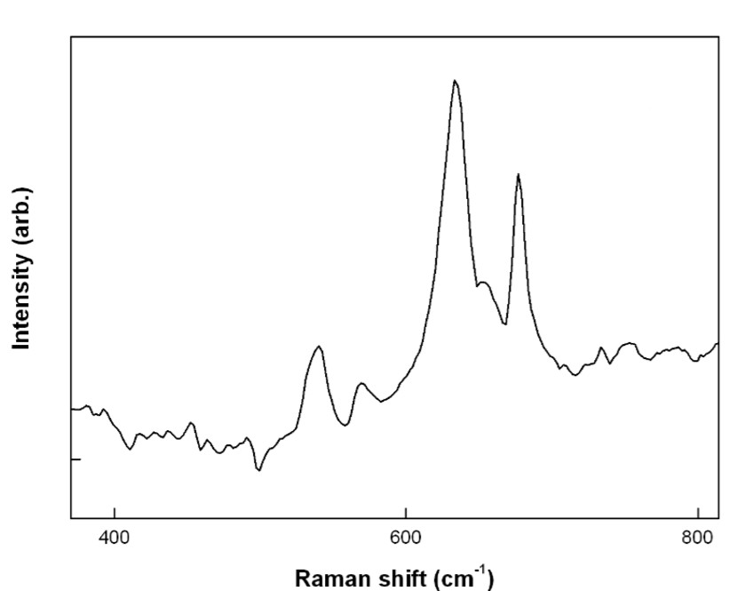

Figure 78: <https://doi.org/10.1117/12.874601>

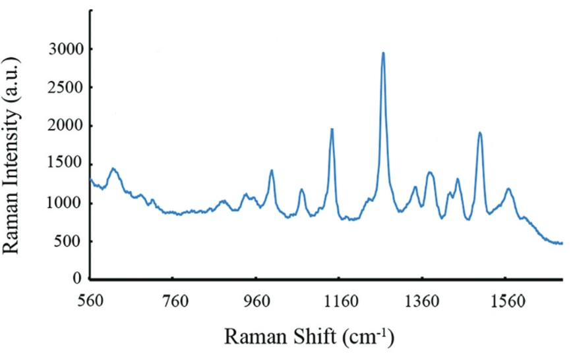

Figure 79:**[10.1039/c8an02086h](https://doi.org/10.1039/c8an02086h" \t "_blank)**

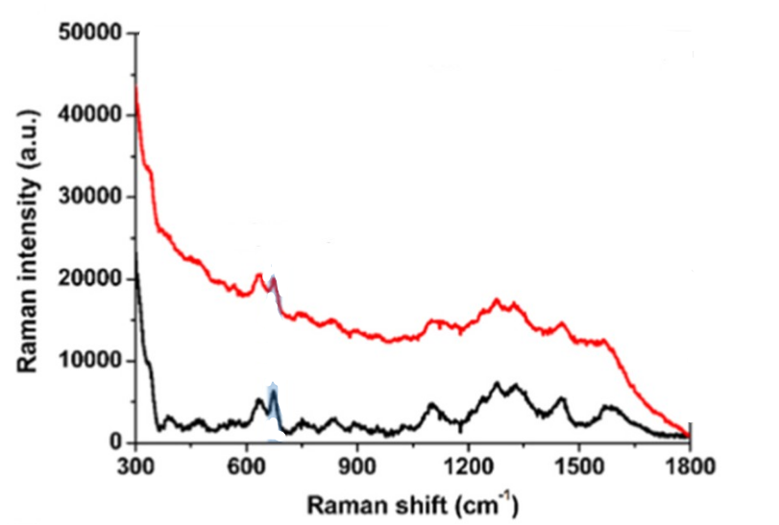

Figure 80:https://doi.org/10.1016/j.snb.2025.138108

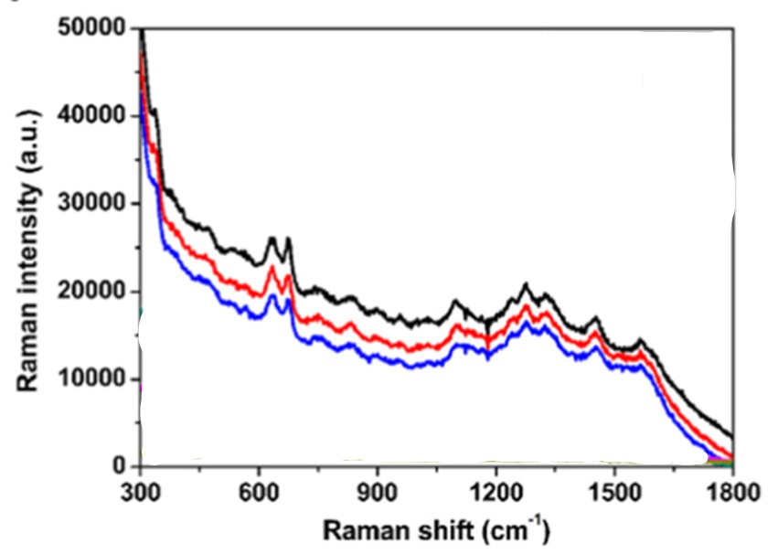

Figure 81:<https://doi.org/10.1016/j.snb.2025.138108>

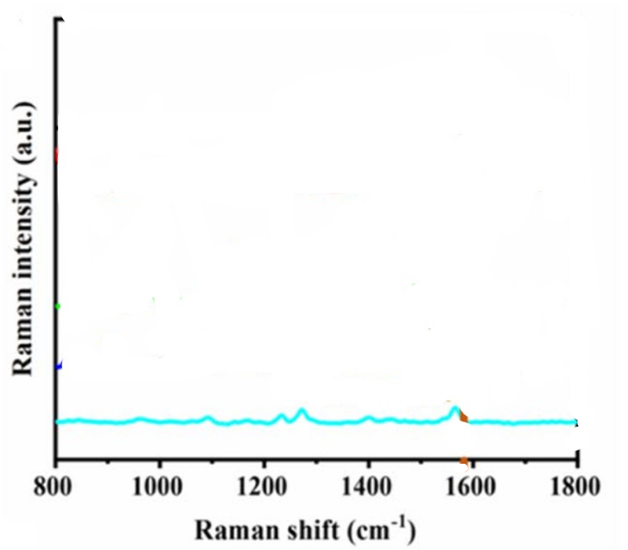

Figure 82:<https://doi.org/10.1007/s00216-023-05055-1>

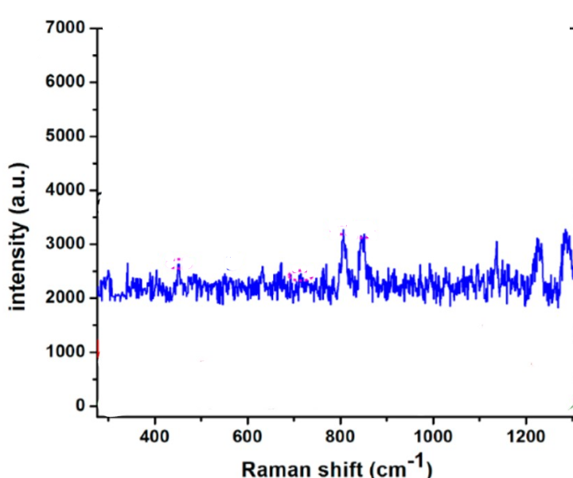

Figure 83:[https://doi.org/10.1021/acsami.7b08818](https://doi.org/10.1021/acsami.7b08818" \o "DOI URL)

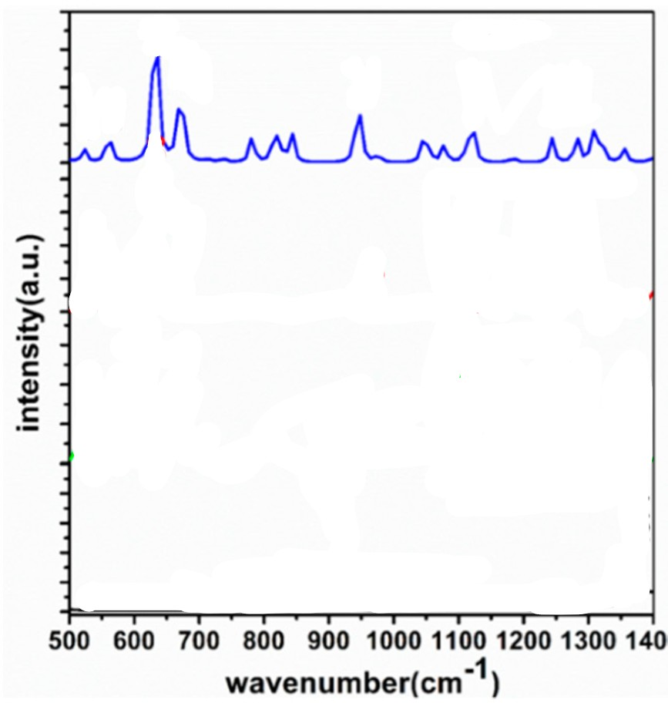

Figure 84: **[ttps://doi.org/10.3390/ijms20112817](https://doi.org/10.3390/ijms20112817)**

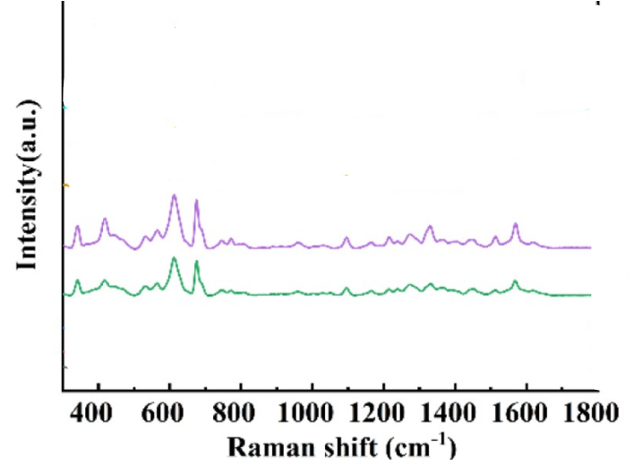

Figure 85:**<https://doi.org/10.3390/foods11081089>**

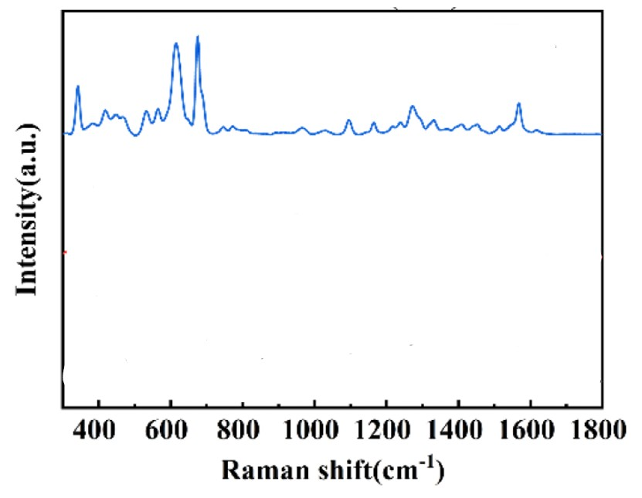

Figure 86:**<https://doi.org/10.3390/foods11081089>**

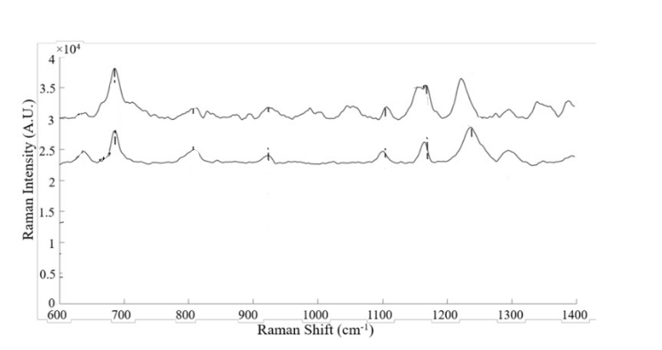

Figure 87:10.14288/1.0402151

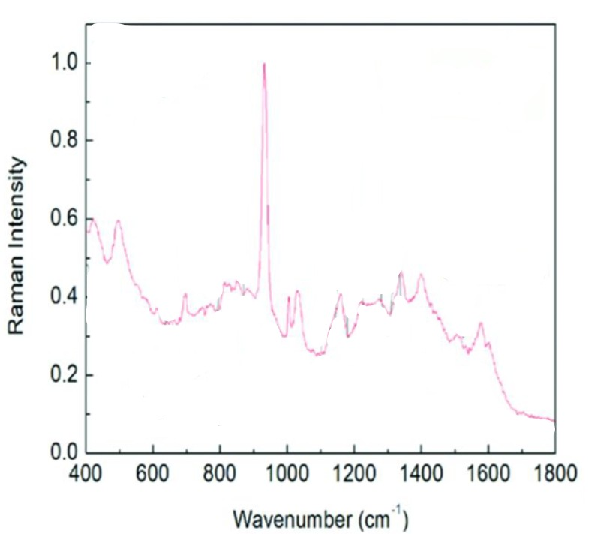

Figure 88:10.1021/bk-2013-1143.ch005

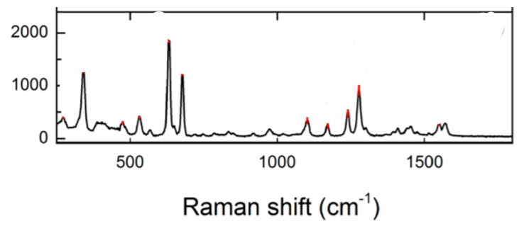

Figure 89:<https://dx.doi.org/10.1021/acs.jpcc.0c06078>

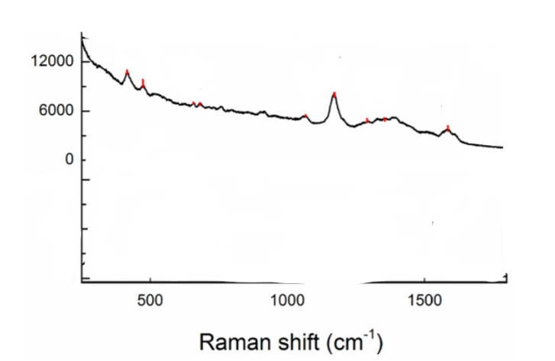

Figure 90:<https://dx.doi.org/10.1021/acs.jpcc.0c06078>

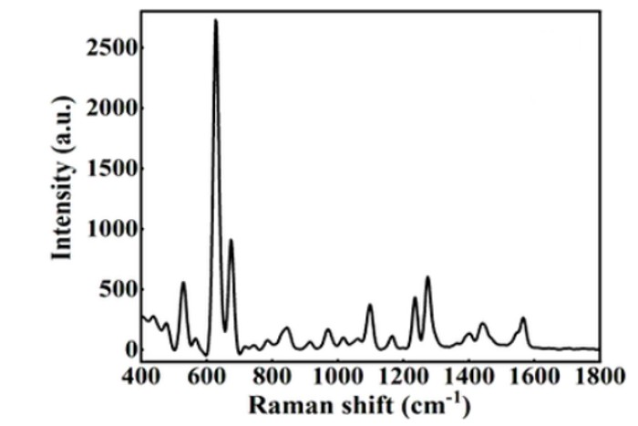

Figure 91:https://doi.org/10.21203/rs.3.rs-2788705/v1

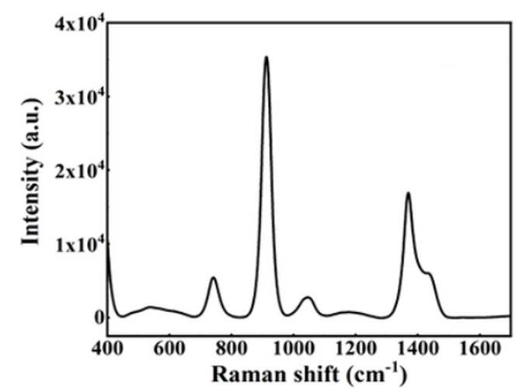

Figure 92:https://doi.org/10.21203/rs.3.rs-2788705/v1

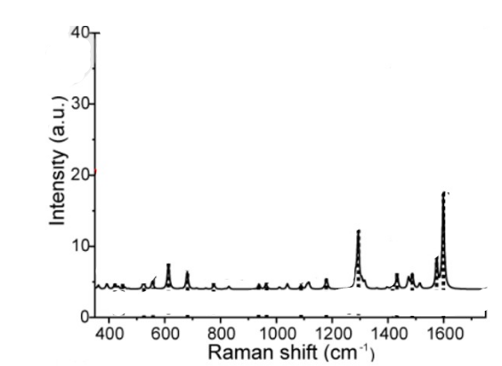

Figure 93 : [https://doi.org/10.1016/j.saa.2023.123665](https://doi.org/10.1016/j.saa.2023.123665" \t "_blank" \o "Persistent link using digital object identifier)

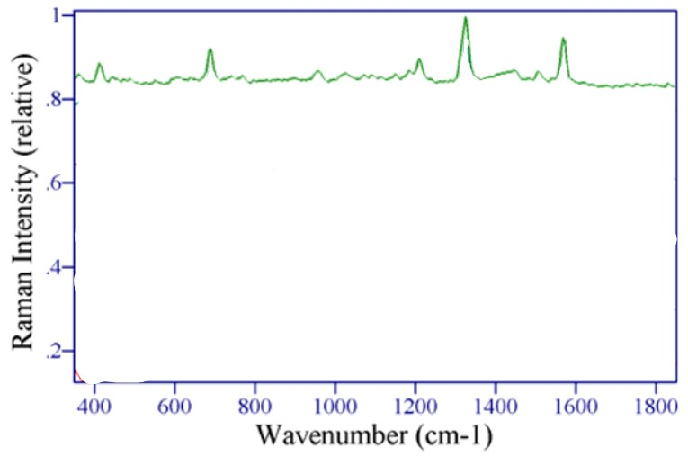

Figure 94:10.1117/12.511941

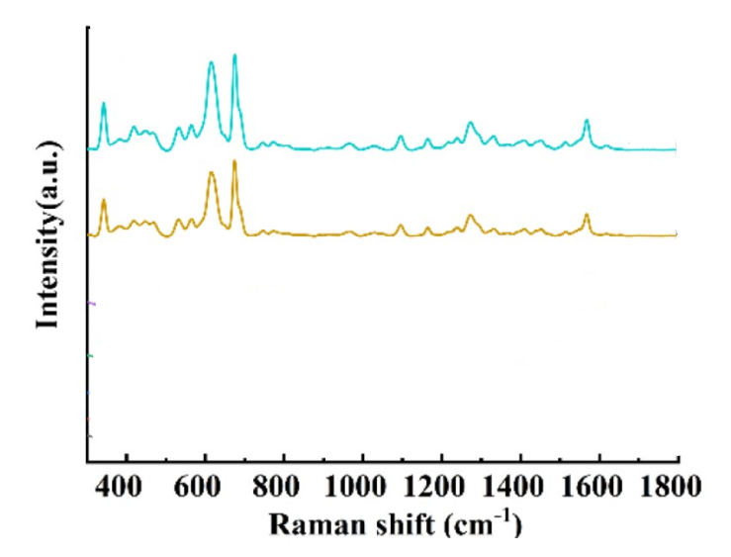

Figure 95: **<https://doi.org/10.3390/foods11081089>**

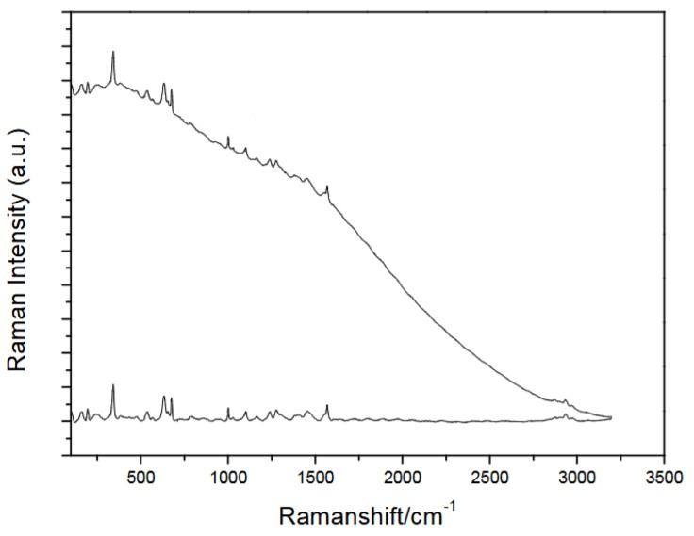

Figure 96: <https://doi.org/10.1117/12.918527>

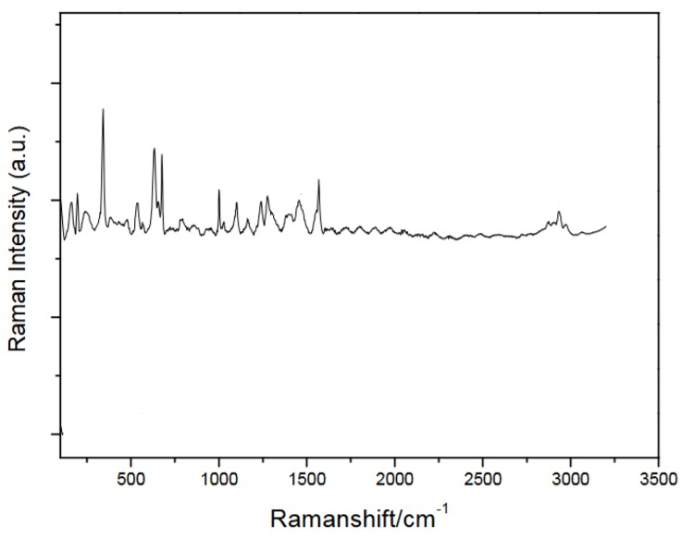

Figure 97: <https://doi.org/10.1117/12.918527>

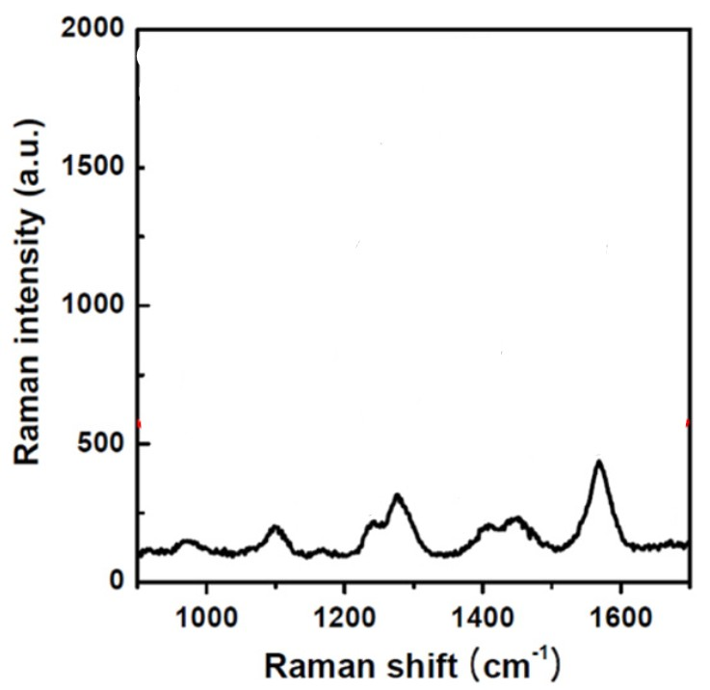

Figure 98: 10.1088/0957-4484/26/1/015502

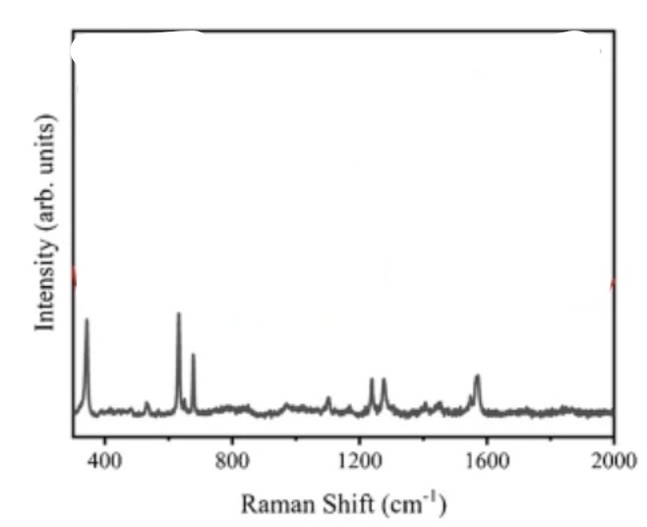

Figure 99: <https://doi.org/10.1007/s00216-025-05903-2>

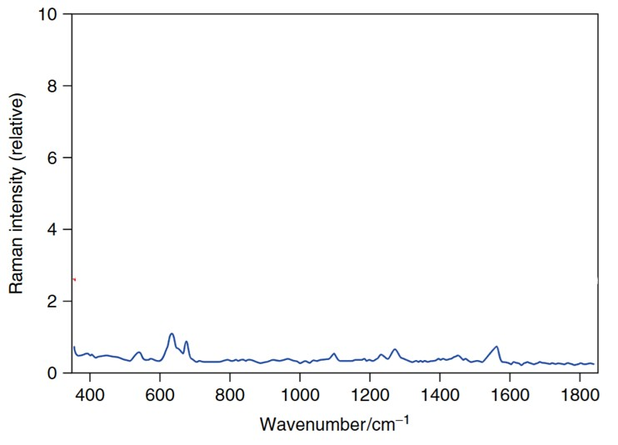

Figure 100: **<https://doi.org/10.1002/0470027320.s8941>**